SUBCOURSE EDITION
SS0601 5

BASIC CIRCUITS OF TELEVISION STUDIO
EQUIPMENT (CAMERAS & AUDIO)



U.S. ARMY RADIO/TELEVISION
SYSTEMS SPECIALIST
MOS 26T, SKILL LEVEL COURSE

BASIC CIRCUITS OF TELEVISION STUDIO EQUIPMENT
(CAMERAS AND AUDIO)

SUBCOURSE NO. SS0601-5

U.S. Army Signal Center
Fort Gordon, Georgia

Five Credit Hours

GENERAL

The Basic Circuits of Television Studio Equipment (cameras and audio) subcourse, part of the Radio/Television Systems Specialist, MOS 26T skill level 1 course, is designed to teach the knowledge necessary for performing tasks related to maintenance and or repair of basic television studio equipment. Information is provided on several tasks which are performed at increasing levels of difficulty at skill levels 1, 2, and 3. The subcourse is presented in three lessons, each lesson corresponding to a terminal objective as indicated below, which will assist personnel in MOS 41E to merge into MOS 26T30 as prescribed by AR 611-201.

Lesson 1: DEFINE BASIC CIRCUITRY THEORIES OF COLOR VIDEO CAMERAS

TASK: Describe theory and terminology of camera pickup tubes, preamplifiers, and video amplifiers.

CONDITIONS: Given information and illustrations about terms relating to television studio equipment, cameras, and about the theory of pickup tubes, preamplifiers and video amplifiers.

i

STANDARDS: Demonstrate competency of the task skills and knowledge by responding to the multiple-choice test covering theory and terminology of basic circuits of a studio color camera.

(This objective supports STP tasks listed at the end of this section.)

Lesson 2: DEFINE BASIC DEFLECTION AND POWER CIRCUITS

TASK: Describe the types of protection deflection circuitry and define dc and ac power.

CONDITIONS: Given information on the function and operation of basic deflection and power circuits, illustrations and characteristics.

STANDARDS: Demonstrate competency of the task skill level and knowledge by responding to the multiple-choice test covering basic deflection and power.

(This objective supports STP tasks listed at the end of this section.)

Lesson 3: DEFINE AUDIO MICROPHONE CIRCUITS

TASK: Describe the uses and operation of four types of microphones and related circuits.

CONDITIONS: Given information and illustrations on the operation and circuitry of the four types of microphones.

STANDARDS: Demonstrate competency of the task skill and knowledge by responding to the multiple-choice test covering audio microphone circuitry of the four types of microphones (carbon, ceramic, dynamic and cardioid).

(This objective supports STP tasks listed at the end of this section.)

The objectives for this subcourse support STP tasks:

113-575-2041 Perform Functional Check of a Color Television (TV) Camera System

113-575-2042 Perform Functional Check of a Television (TV) Studio Camera Color-Plexer

113-575-2043 Perform Functional Check of a Television (TV; Studio Color Camera

113-575-0043 Troubleshoot a Color Television (TV) Studio Camera

113-575-3040 Inspect a Repaired Television (TV) Camera

ii

Also, the following shared task is referenced from MOS 84F, STP 11-8413-SM-TC:

113-577-1039 Select a Microphone

iii

TABLE OF CONTENTS

Section Page

TITLE PAGE i

TABLE OF CONTENTS iv

INTRODUCTION TO BASIC CIRCUITS OF TELEVISION STUDIO EQUIPMENT (CAMERAS
AND AUDIO) vii

Lesson 1: DEFINE BASIC CIRCUIT THEORIES OF COLOR VIDEO CAMERAS 1

Learning Event 1: Describe the Theory of a Pickup Tube 1

Learning Event 2: Describe the Theory of the Preamplifier Circuit
3

Learning Event 3: Describe the Theory of Video Amplifiers 6

Practice Exercise 9

Answers to Practice Exercise 11

Lesson 2: DEFINE BASIC DEFLECTION AND POWER CIRCUITS 12

Learning Event 1: Describe the Function of Deflection Protection
Circuits 12

Learning Event 2: Describe the Function of DC Power Circuits 17

Learning Event 3: Describe the Function of AC Power Circuitry 19

Practice Exercise 20

Answers to Practice Exercise 22

Lesson 3: DEFINE AUDIO MICROPHONE CIRCUITS 23

Learning Event 1: Describe Use and Operation of a Carbon Micro-
phone 23

iv

Learning Event 2: Describe Uses and Operation of the Ceramic and
Dynamic Microphones 28

Learning Event 3: Describe Uses and Operation of the Cardioid
Microphone 31

Practice Exercise 35

Answers to the Practice Exercise 37

GLOSSARY 38

FULL PAGE FOLDOUTS 45

v

INTRODUCTION TO BASIC CIRCUITS
OF TELEVISION STUDIO EQUIPMENT
(Cameras and Audio)

The density and complexity of today's military television activities require a technician capable of performing his job using his knowledge, experience, and proper techniques in the successful completion of the mission. The purpose of this subcourse is to provide the soldier with an overall view of two of the critical areas he will work in using television studio equipment: television cameras, and audio equipment (microphones and related circuitry). It is also meant to assist MOS 41E personnel to merge into MOS 26T30, as prescribed by AR 611-201, and provide entry level training information for any soldier desiring to cross-train into MOS 26T.

vii

LESSON 1
DEFINE BASIC CIRCUIT THEORIES OF COLOR VIDEO CAMERAS

TASK

Describe theory and terminology of camera pickup tubes, preamplifiers, and video amplifiers.

CONDITIONS

Given information and illustrations about terms relating to television studio equipment cameras, describing the theories of pickup tubes, preamplifier and video amplifier.

STANDARDS

Demonstrate competency of the task skills and knowledges by responding to the multiple-choice test covering theory and terminology of the basic circuits of a color studio camera.

REFERENCES

None

Learning Event 1:
DESCRIBE THE THEORY OF A PICKUP TUBE

1. Color video cameras are basically alike in many ways: they all have pickup tubes, preamplification, video amplification, camera cable, DC power, AC power, and deflection circuitry.

NOTE: Color video cameras basically take an image of light and convert it into electronic information.

2. The common characteristic of all pickup tubes is conversion of light images into electronic reproduction of those images. The most commonly used pickup tube is the plumbicon.

3. The plumbicon tube is a photoconductive device. This means it conducts when the face is struck by light: in reverse, when the photo-conductive layer is not struck by light, then the photo-conductive layer will not conduct (fig 1-1 foldout located at the end of Lesson 3). The electron beam is obtained from the cathode of the pickup tube. As voltage is applied to the heater the cathode emits free electrons.

1

a. These electrons are guided through the pickup tube by grids 1, 2, 3, and 4. These grids control magnitude, focus and acceleration of the electron beam on its way to the target. If any of these grids are defective in any way, they will cause focus problems or damage to the target.

b. These voltages and currents must be checked frequently for maximum tube performance and life. Let's put the entire pickup tube operation in sequence and see how it works:

(1) Power is applied to all required inputs.

(2) The heater heats the cathode and then emits electrons.

(3) Acceleration grids control the speed and magnitude of the electron beam.

(4) The faceplate of the pickup tube is exposed to a light image: this means it is conducting.

(5) The electron beam strikes the photoconductive portion of the pickup tube, and a small amount of current is passed from the target to the preamplification circuitry.

(6) The electron beam has traced the entire face of the pickup tube: at this time, a sufficiently large amount of voltage (blanking) is applied to the cathode during retrace. This blanking pulse will not allow the retrace line to be visible.

NOTE: Remember, this is basically the operation of a pickup tube. The pickup tube passes its electronic information into the preamplification circuitry. ALWAYS refer to the manufacturer's manual for correct voltages and current applicable for your specific camera.

2

Learning Event 2:
DESCRIBE THE THEORY OF THE PREAMPLIFIER CIRCUITRY

1. Preamplifier. For every pickup tube in a studio camera head there is always preamplification circuitry. Studio color cameras have three pickup tubes; consequently, they have three preamplifiers.

2. Operation of a Preamplifier. What does preamplification do for the camera head? First of all, it receives a high current low voltage input from the target of the pickup tube. This DC-coupled signal is changed within the preamplifiers to a stable voltage output which goes to its respective video amplifier circuitry input (fig 1-2 foldout located at the end of Lesson 3).

3. Circuitry of a Preamplifier. The most common examples of circuitry of a preamplifier are the following (fig 1-2).

a. The bias adjust circuit permits adjustment of the preamplifier video output to zero volts DC at black level. This normalizes the DC bias levels for the entire preamplifier.

(1) What is bias? Bias is a negative or positive voltage that either turns on, turns off, or regulates the voltage and current output of the electronic device.

(2) Black level is a constant voltage that video references to.

b. The mid-range and low frequency circuits are common in preamplifiers. They are used to shape the video wave form and reduce unwanted peaking caused by stray capacitance.

c. The video gain is set according to the manufacturer's manual. The video gain control biases the video amplifier stage of the preamplifier stage, so it will conduct and amplify the video signal to the manufacturer's specifications.

4. Basic Operation. The video signal is sent from the target of the pickup tube to the input of the preamplifier (fig 1-3).

3

Lesson 1/Learning Event 2

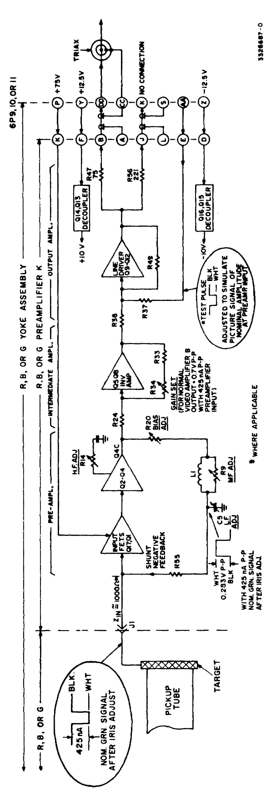

Figure 1-3. Preamplifier K Module 1 block diagram

4

Lesson 1/Learning Event 2

a. In the first stage, the signal is stabilized and a high signal to noise ratio is achieved. The video signal is sent to the second stage, where it is amplified and processed by the frequency adjustments to stop stray capacitance and correct symmetry. The video signal is sent from this stage to the third stage, where it is inverted and amplified again, then sent to the line driver.

b. The line driver amplifies the video signal and sends the signal out to its respective video amplifier, where it is terminated into 75 ohms. The preamplifier has now converted an unstable current input into a stable voltage output.

5

Lesson 1/Learning Event 3

Learning Event 3:
DESCRIBE THE THEORY OF VIDEO AMPLIFIERS

1. General. The video amplifier performs certain basic functions for the red, blue, and green signal paths within the camera head. These include: beam set, sensitivity, clamping, clipping, and distribution of the video signal (fig 1-4, a foldout located at the end of Lesson 3).

2. Input First Stage Amplification. Video output from each of the three preamplifiers is fed to the corresponding video amplifier and terminated into a 75-ohm load. The video signal is sent through an attenuator circuit in order to establish a typical 2/1 beam reserve ration.

a. From the beam set circuit the video signal is sent to an amplifier stage where the video gain is set to a predetermined voltage, (manufacturer's technical manual).

b. If the video gain amplifier is a fixed gain type, it is important that the video gain setting located on the preamplifier board is set to manufacturer's specifications.

3. The sensitivity circuitry controls the signal current (fig 1-4). This is accomplished by attenuating or padding the video signal. Commonly, there are two types of sensitivity circuits:

a. The high sensitivity circuit is used when there is a low current signal; it reduces the attenuation, or resistance, which allows the video signal to proceed at a higher value.

b. The low sensitivity circuitry is used when too much current is available in the video signal. When this circuit is engaged, the overall resistance is increased, which attenuates the signal current and reduces the signal to an acceptable level.

NOTE: When using the sensitivity circuitry you may change the BEAM DISCHARGE CHARACTERISTICS.

4. Fixed Amplifier. The video signal then is passed to a fixed amplifier (fig 1-4). This is a non-inverting amplifier of high stability. The video signal is sent from this stage to the final stage of the video amplifier for processing.

6

Lesson 1/Learning Event 3

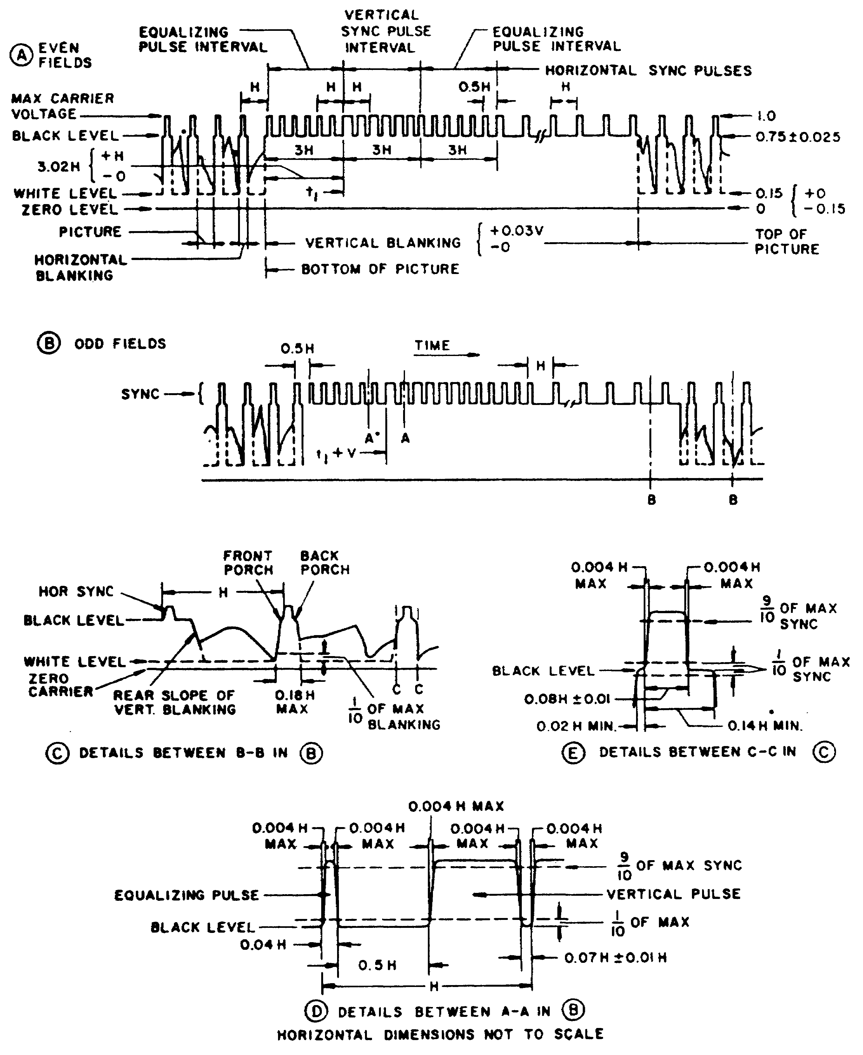
Figure 1-5. Detailed dimensions of FCC standard synchronization waveform

7

Lesson 1/Learning Event 3

5. Clamp. When the signal arrives at the clamping circuit it is forced to maintain a constant DC reference level which is produced by the clamp circuitry. Suppose you were responsible for maintaining a level of exactly one inch of water leaving a dam and you use a flood gate to regulate the water flow over the dam. A clamping voltage would accomplish this same type of regulation in a circuit.

6. Blanking. The signal has been clamped at a constant DC reference, before it enters the blanker. The signals blanking level which is 75 percent of peak carrier amplitude to which the horizontal and vertical blanking pulses rise are cleaned up of any spurious voltages and sent to the white clipping stage.

7. Clamped and blanked video arrives at the white clipper stage. This circuit effectively removes large high light information, thereby easing the dynamic range requirements for the camera control circuitry and the viewfinder. The function of this circuit can easily be understood if you compare the video to hedge rows and the white clipper to hedge clippers. Hedges grow unevenly at the top. The hedge clipper and white clipper both chop off unwanted peaks. This makes the video, or bush, flat across the top.

8. Outputs. The first output of the video amplifier is sent to a noninverting amplifier which sets the video signal voltage to the manufacturer's specifications and feeds the signal to the viewfinder circuitry (fig 1-4 foldout located at the end of Lesson 3).

a. The second video output is sent to a preequalization network, which preemphasizes and boosts the video signal to counteract for signal loss through the camera cable over long distances.

b. If the camera cable length is short, 50 feet or less, preemphasis is not necessary. The camera cable driver outputs the video signal through the camera cable to the camera control unit.

8

PRACTICE EXERCISE

1. How many grids are typically used for controlling the electron beam?

a. 2 c. 4
b. 3 d. 5

2. What type of pickup tube is most commonly used?

a. Plumbicon c. Orthicon
b. Vidicon d. Trinitron

3. What circuitry receives the output of the pickup tube?

a. RF amplifier c. IF amplifier
b. Preamplifier d. Viewfinder

4. What causes the cathode to emit electron flow?

a. Heat c. Positive electrons
b. Cooling d. Coldness

5. What is the name of the voltage applied to the pickup tube so you do not see retrace?

a. Spacing c. Direct
b. Blanking d. Quazar effect

6. What term describes the amount of current which is passed from the pickup tube to the preamplifier?

a. Heavy c. Small
b. Moderate d. Very heavy

7. A preamplifier receives its respective video input from where?

a. G-3 of the pickup tube
b. Cathode of the pickup tube
c. Light source
d. Target of the pickup tube

8. What does the first stage of preamplification accomplish?

a. A low current input converted to a stable voltage output
b. Achieves a high signal to noise ratio
c. Corrects an unstable voltage into a correct and stable current
d. Attenuation achieves a high signal to noise ratio

9

9. Three-tube studio cameras have how many preamplifiers?

a. 4 c. 3
b. 2 d. 1

10. When the preamplifier has completed the processing of the video signal, what has it accomplished?

a. Amplification of the video signal
b. Established a good signal to noise ratio
c. Converted a low current input into a stable voltage output
d. Has added burst reference

11. The preamplifier always follows what major stage of the video camera?

a. Deflection stage c. Image stage
b. Power stage d. Pickup tube stage

12. The input to each video amplifier is derived from what previous stage?

a. Vertical deflection stage
b. Pickup tube stage
c. Preamplifier stage
d. Audio output stage

13. What is the typical beam reserve setting for a video camera?

a. 6 to 1 c. 3 to 1
b. 1 to 1 d. 2 to 1

14. What does the sensitivity circuit control?

a. dB c. Voltage
b. Current d. Impedance

15. What is the purpose of a clamp circuit?

a. Stops spurious highlights
b. Set frequency of sync pulse
c. Set reference for video and sync
d. Used as a timing pulse

16. A white clipper is used to correct what?

a. Spurious peaks c. Amplitude
b. Current d. Frequency

10

ANSWERS TO PRACTICE EXERCISE FOR LESSON 1

1. C
2. A
3. B
4. A
5. B
6. C
7. D
8. B
9. C
10. C
11. D
12. C
13. D
14. B
15. C
16. A

11

LESSON 2
DEFINE BASIC DEFLECTION AND POWER CIRCUITS

TASK

Describe the types of protection deflection circuitry and define DC and AC power.

CONDITIONS

Given information on the function and operation of basic deflection and power circuits, illustrations and characteristics.

STANDARDS

Demonstrate competency of the task skill and knowledge by responding to the multiple-choice test covering basic deflection and power circuits.

REFERENCES

None

Learning Event 1:
DESCRIBE FUNCTION OF DEFLECTION PROTECTION CIRCUITRY

1. General. The deflection system is designed with stable, precise, operational amplifiers. These amplifiers are capable of handling the DC as well as AC requirements for centering and deflection. The inputs of these amplifiers are DC-centering voltages and the required drive waveforms which are basically sawtooth voltages.

2. Precise tracking of the red, blue, and green channels is obtained by driving the three horizontal amplifiers from one master sawtooth generator, which is very stable.

3. Differential registration is controlled by the camera control unit (CCU). This is accomplished by varying DC voltages sent by the CCU to the master sawtooth generator which controls differential registration.

a. The voltages from the CCU are carried to the master sawtooth generator located in the camera head by the camera cable. This cable is connected at the back of the CCU and run to the camera.

b. Camera cables are not the same length. If the length of the camera cable changes, this also changes the impedance.

12

(1) If the impedance changes, then stabilization is lost to the input of the master sawtooth generator.

(2) To prevent an impedance change, a pad or attenuation system is in series with the camera cable.

4. Horizontal Deflection System (fig 2-1, a foldout located at the end of Lesson 3). Horizontal deflection starts with horizontal drive which is obtained from the camera pulse module that putt: out a negative-going pulse. The drive signal is isolated by emitter follower Q15, and is then applied to the horizontal sawtooth generator circuit.

a. A master sawtooth waveform is generated by charging C1 through Q1, and discharging it through Q2. Transistor Q3, an emitter follower, isolates and prevents loading of the capacitor charging circuits.

b. Sinusoidal retrace is required to minimize spurious transients in the yoke during horizontal retrace.

c. The output of emitter follower, Q3, applies the master sawtooth waveform to each individual horizontal deflection amplifier on the horizontal deflection module. This waveform would deflect the beam within the pickup tube horizontally, and within tolerance if no differential errors existed, d. Differential. correction waveforms are added to the master sawtooth waveforms in the individual channels, which will provide differential linearity and width correction.

NOTE: The rest of the lesson on horizontal deflection will be on the red channel. All channels are basically the same (fig 2-2).

5. Red differential width controls the horizontal movement of the red electron beam across the target of the pickup tube. This is accomplished by feeding a DC control voltage through the camera cable and resistor R77 and applying it to a capacitor which is discharged at a horizontal rate by transistor Q19.

a. The sawtooth which is developed by this circuitry can be either negative or positive in potential. This negative or positive signal is then added to the Red master sawtooth waveform. The end result is the ability to increase or decrease the width of Red master horizontal deflection.

b. Red differential horizontal linearity is achieved by first generating a sawtooth waveform in the same way it is done within the red width control, except that only a positive sawtooth is needed.

c. The sawtooth is applied to an integrator circuit which converts the sawtooth waveform into a positive parabola waveform. From this addition, horizontal linearity is obtained.

13

d. Red differential skew control is accomplished by feeding a negative or positive voltage to the red skew generator. The Red skew generator, in turn, feeds the master sawtooth generator, a sawtooth waveform, at a vertical rate. This voltage is added to the master sawtooth waveform and horizontal skew is obtained.

e. The red horizontal deflection amplifier can be easily described by referring to the circuit diagram of the Red horizontal deflection amplifier (fig 2-2).

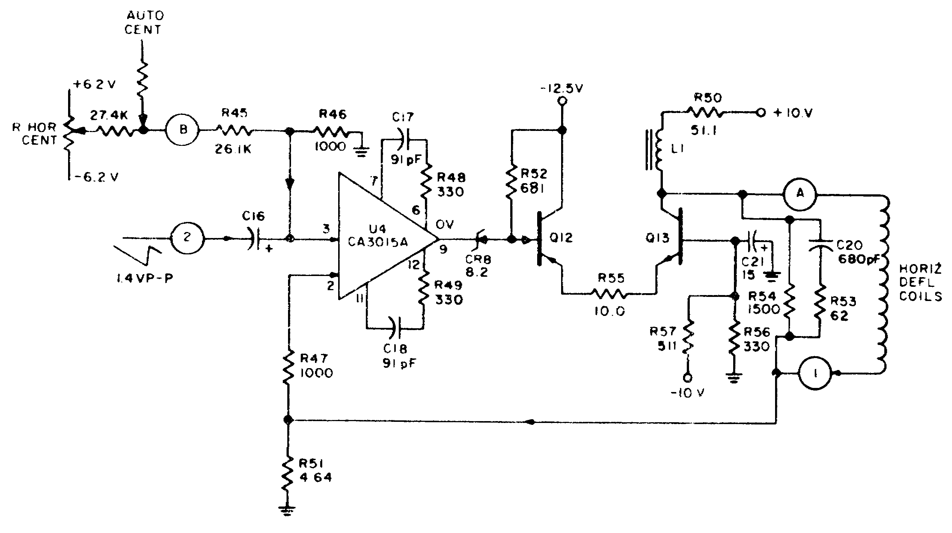

Figure 2-2. Red horizontal deflection amplifier, Sch Dia

f. The master sawtooth waveforms with the added differential corrections are applied to the horizontal deflection amplifiers located on the deflection amplifier module. These amplifiers are basically differential input operational types which compare the deflection current samples with the applied deflection waveforms. Precise tracking of reference and applied current are obtained through this circuit.

6. Vertical Deflection System (fig 2-3 foldout located at the end of Lesson 3). Vertical deflection starts with vertical drive pulses which are obtained from the Camera Pulse Module at a negative level. The first stage input transistor, Q22, isolates the external drive signal from the module and prevents excessive loading of the drive signal.

a. The drive signal feeds Q8 which discharges a capacitor that is charged by current source Q7. Emitter follower Q9 prevents loading of the capacitor charging circuit, thereby maintaining sawtooth linearity. The time constant of this circuit has been chosen to provide exceptional linearity characteristics.

14

b. The master height control is accomplished by varying the emitter resistance of the current source, Q7. The output of Q9 feeds the master sawtooth waveform to the individual vertical deflection amplifier.

(1) This waveform would suffice to deflect, vertically, the three pickup tube beams if differential error were not present.

(2) It remains, therefore, to add to the master sawtooth waveforms in three individual channels, differential linearity and height correction.

NOTE: From this point forward only the red deflection system will be discussed (fig 2-3A).

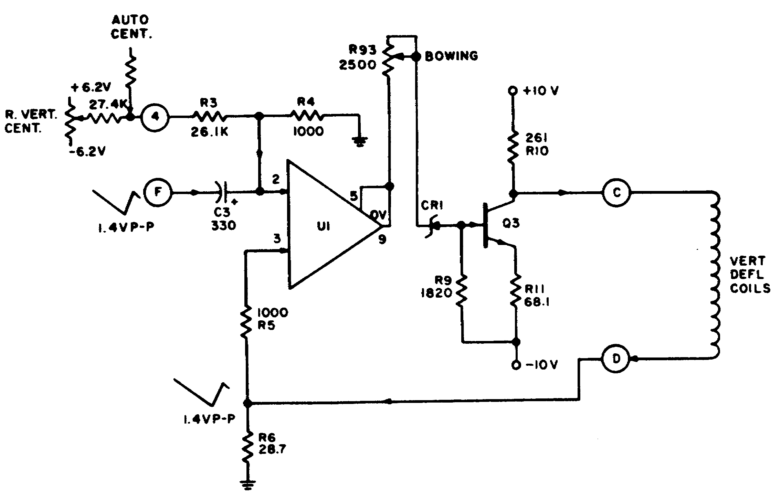

Figure 2-3A. Red vertical deflection amplifier, sch dia

c. Red differential height control is obtained by feeding a DC control voltage through the camera cable and applying it to a capacitor which is discharged at a vertical rate.

(1) The sawtooth signal which is developed can be negative or positive, depending on the setting of the red height control at the registration module.

(2) This signal is then added to the red master sawtooth waveform, thereby adding to or subtracting from the overall Red height control.

15

d. Red differential vertical linearity control is achieved by first generating a sawtooth waveform as is done in the red height control circuit.

(1) The remotely controlled sawtooth waveform, which is sent from the CCU, is then applied to an integrator circuit which converts the sawtooth to a negative or positive going parabola.

(2) The parabolic waveform is then added to the master sawtooth waveform, thereby producing differential linearity correction.

e. The master sawtooth waveform with the added differential corrections described this far are then applied to the vertical deflection amplifier module. These amplifiers are basically differential input operational types which compare the deflection current samples with the applied deflection waveforms.

(1) The loop gains of these amplifiers are such that precise tracking of the reference and current sample waveforms is obtained.

(2) Capacitive coupling is used at the input of the deflection amplifiers so that centering voltages are not dependent on the DC potential of the centering waveforms.

f. Deflection failure protection is obtained by adding the three horizontal and the three vertical current samples at the protection amplifier. (fig 2-4, foldout located at end of Lesson 3).

(1) All six of these input voltages are maintained at a constant peak to peak voltage level and the protection circuitry is biased on and is passing the correct amount of voltage to grid 2 (G2) of the pickup tube.

(2) If any of the six input voltages vary by 75 percent, the protection circuitry will be biased off causing the voltage to C2 to be grounded; thus giving G2 a 0 volt potential and stopping conduction within the pickup tube. This process protects the target of the pickup tube; otherwise without deflection, the electron beam would strike the target in one single area causing damage to the target.

16

Learning Event 2:
DESCRIBE FUNCTION OF DC POWER CIRCUITRY

1. General. All DC power required by the camera head is supplied from the power supply frame. The output of the DC power supply is connected to the camera cable and inputted to the camera head.

2. The DC converter module works in combination with the DC converter control module, at the camera head, to act as a DC transformer. The transformer changes a high DC voltage, low current supply, to low DC voltage, high current supply. The low voltage obtained is used by the camera head modules.

3. The common voltages needed to operate a studio camera are high voltage, G-2 voltage, focus current, heater supply voltage, and various regulated and unregulated voltages.

a. High Voltage (fig 2-5 foldout located at end of Lesson 3). High voltage AC from transformer T101 in the power supply is full wave rectified by a diode network and filtered capacitively. A shunt regulator provides additional filtering and regulation.

(1) The next circuitry involved is a resistive network. This resistive network divides the high voltage down to a nominal working voltage. This working voltage is compared to a reference voltage.

(2) Reference voltage is compared to the divider voltage and the amplified error signal is applied to the shunt regulator so that it draws more current if the compared voltage increases, and less current if the voltage decreases.

(3) The result is that a constant DC voltage output is maintained.

(4) The voltage supply for the control amplifier is obtained from the unregulated 150 volt positive supply through R15. Zener diodes CR20 and CR21 provide regulated voltage sources.

b. G2 voltage (positive 285 volts). Diodes CR13 through CR16 and capacitor C1 fullwave rectify and filter the AC from power transformer T101. The filtered DC is fed through an overload protection circuit to a series regulator.

(1) The base voltage of the driver transistor Q4 is obtained from a resistive voltage divider and connected across the +930 volt supply, which establishes the +285 volt output.

(2) The +285 volt output feeds through the power supply cable to the camera cable and is passed to the deflection module, located in the camera head (fig 1-2 foldout located at the end of Lesson 3).

c. Focus Current. (129 ma). This is a stable current and compensates for input voltage and load resistance changes.

(1) This circuit is basically a comparator-type circuit. The amplified error signal is sent to the series regulator which maintains a constant current of 129 ma.

17

(2) The focus current source is routed through the power cable to camera cable and then to the focus coils and the deflection assembly (fig 1-2 foldout).

d. Heater Supply Voltage. This is the negative 12.5 volts which is used for a DC heater voltage source. The -12.5 volts is divided in half to provide two 6.25 volt DC heater sources. The three pickup tube filaments are connected in parallel between -12.5 volts and -6.25 volts, and the viewfinder kinescope heater is connected between -6.25 volts and ground.

e. The -160 Regulated Supply. This voltage is obtained from transformer T101. It is rectified and filtered by a fullwave bridge rectifier and capacitively filtered and then fed to the series regulator. The series regulator is a high gain emitter follower circuit. The output is felt on Zener diode CR39 which establishes the output voltage.

(1) The DC supply for the reference Zener diode is obtained from a fullwave rectifier and then capacitively filtered; fuse F111 provides overload protection.

(2) The output of the -160 volt regulated supply feeds through the power supply cable to the target and beam controls (fig 1-2 foldout).

f. The 150 volt Unregulated Power Supply. This voltage is obtained from transformer T101. The output of transformer T101 is fullwave rectified and filtered at the input to the 150 volt power supply. Overload protection is provided by fuse F109.

(1) The developed -150 volt, and +150 volt supplies are sent through the power cable to the camera head where they are used to develop the -12.5 volts, the 12.5 volts, the -60 volts, as well as direct power for the viewfinder.

(2) The -60 Regulated Supply. This is the voltage used for target blanking and is derived from the -150 volt unregulated supply.

18

Lesson 2/Learning Event

Learning Event 3:
DESCRIBE FUNCTION OF AC POWER CIRCUITRY

1. General. AC power is the basis for all power within the camera system. The normal AC power available within the United States is 120 volts at 60 hertz.

2. Camera head AC power is supplied by the center tapped-to-ground secondary winding at transformer T101 in the power supply. This voltage is approximately 120 volts on either side of ground for nominal voltage input.

3. In order to minimize the possibilities of AC signal appearing in the camera cable ground, and to prevent power transients from being induced on the video coaxial cable, camera AC is not returned to ground outside of the power supply frame.

4. To attenuate the small amount of even harmonic distortion caused by the DC supplies within the power supply frame, AC is filtered before leaving its
respective power supply frame (fig 2-6, located at end of Lesson 3).

19

PRACTICE EXERCISE

1. Where is the master sawtooth generator located?

a. Camera cable c. Camera head
b. Viewfinder d. Preamplifier

2. What changes if the length of a camera cable is changed?

a. Voltage c. Impedance
b. Current d. Capacitance

3. What pulse input activates horizontal deflection?

a. Horizontal advanced c. Horizontal drive
b. Vertical blanking d. Negative parabolic

4. What is the polarity of the DC potential voltage developed for horizontal width control?

a. Negative sawtooth
b. Positive or negative sawtooth
c. Positive sawtooth
d. Pulsed at 10 volts

5. What is the polarity of the DC voltage generated to control horizontal linearity?

a. Positive sawtooth
b. Negative and positive sawtooth
c. Negative sawtooth
d. Zero potential

6. How many inputs are present for the protection circuitry to be on?

a. 10 c. 5
b. 6 d. t

7. Which grid within the pickup tube is biased to 0 volts by the protection
circuit?

a. G-2 c. G-3
b. G-1 d. G-4

8. Where are the DC voltages generated?

a. Camera head
b. DC power supply main frame
c. DC power supply secondary frame
d. Master generator

20

9. What path do the DC voltages take to arrive at the camera head?

a. Camera cable a. Most common indirect
b. Viewfinder cable d. Direct

10. What does focus current compensate for?

a. Lighting changes
b. Input voltage and load changes
c. Blanking
d. Viewfinder contrast levels

11. The 150 volt supply gives direct power to what?

a. Preamplifier c. Pickup tube
b. Microphones d. Viewfinder

12. What value is heater supply voltage?

a. -150 volts c. -12.5 volts
b. +12.5 volts d. +160 volts

13. Where is AC power returned to ground?

a. Camera head c. Viewfinder
b. Power supply d. Camera cable

14. What is the purpose of filtering the AC before it leaves the power supply frame?

a. To stop even harmonic distortion
b. To stop odd harmonic distortion
c. To enhance harmonic distortion
d. To increase voltage

15. What causes transient voltages to appear in the video coax cable?

a. Voltage set too high c. Too little negative voltage
b. A ground problem d. Too much positive voltage

21

ANSWERS TO PRACTICE EXERCISES FOR LESSON 2

1. C
2. C
3. C
4. B
5. A
6. B
7. A
8. B
9. A
10. B
11. D
12. C
13. B
14. A
15. B

22

LESSON 3
DEFINE AUDIO MICROPHONE CIRCUITS

TASK

Describe the uses and operation of four types of microphones and related circuits.

CONDITIONS

Given information and illustrations on the operation and circuitry of four types of microphones.

STANDARDS

Demonstrate competency task skill and knowledge by responding to the multiple-choice test covering audio microphone circuitry of the four types of microphones; carbon, ceramic, dynamic and cardioid.

Learning Event 1:
DESCRIBE USES AND OPERATION OF A CARBON MICROPHONE

1. Microphones. Microphones may be classified according to their physical design, such as carbon, capacitor, ribbon-velocity, moving coil, semi-conductor and ceramic. Special use microphones such as dual, in-line, and high intensity microphones will also be discussed in this lesson.

2. What is a microphone? A microphone is a device which converts acoustical energy into electrical energy. Microphones can be also called an electroacoustic transducer.

3. Basic Principles of Microphone Operation. Microphones are divided into two categories of operation; velocity and pressure.

a. Pressure-operated microphones employ a diaphragm with only one surface exposed to the sound source. The displacement of the diaphragm is proportional to the instantaneous pressure of the sound wave. At lower frequencies such microphones are practically nondirectional.

b. A velocity microphone is one in which the electrical response corresponds closely to the sound input. A velocity microphone can also be called a gradient microphone. A gradient microphone is a microphone that corresponds to the gradient of sound pressure exerted upon it.

4. Polar Field Patterns. A polar field pattern is a plot employing polar coordinates, showing the magnitude of sound quality in some or all directions from a given point for 360 degrees. Polar plots are used to present the direc-

23

tional patterns of microphones; the term field pattern is interchangeable with the term polar pattern. Basically, there are four types of polar patterns (fig 3-1).

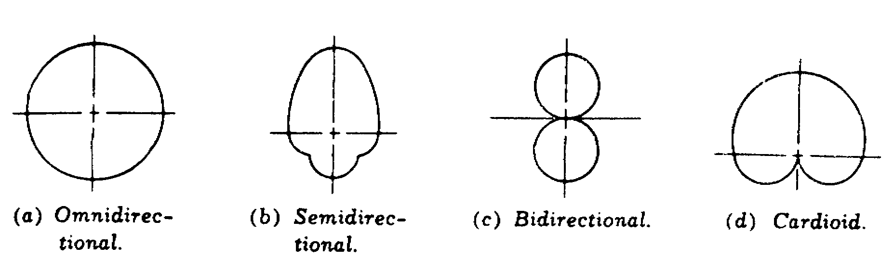

Figure 3-1. Basic microphone field patterns

a. The omnidirectional is a circular, or non-directional field pattern, representing the crystal, dynamic, capacitor, carbon, electronic frequency modulated, and inductor type microphones.

b. The semidirectional pattern obtained with an adjustable field pattern microphone is illustrated in Figure 3-1. As the pattern shows, this type of microphone is directional at high frequencies but nondirectional at low frequencies.

c. The bidirectional pattern obtained with a ribbon microphone is also illustrated by figure 3-1. The microphone is essentially dead to pickup at the sides. This pattern is generally referred to as the figure-eight field pattern.

d. Cardioid. Microphones are available that will fit the field pattern to be varied to fit almost any situation and include all of the foregoing patterns in some form or the other.

5. Carbon Microphones. How is a carbon microphone constructed and what is its principle of operation? Several hundred small carbon granules are held in close contact in a brass cup called a button, which is attached to the center of a metallic diaphragm. Sound waves striking the surface of the diaphragm disturb the carbon granules, changing the contact resistance between their surfaces.

a. The change in contact causes a current from a battery connected in series with the carbon button and a primary of a transformer to vary in amplitude, resulting in a current waveform similar to the acoustic waveform striking the diaphragm.

b. After leaving the secondary of the transformer, the minute changes current through the transformer primary are amplified and reproduced in a conventional manner. Figure 3-2 shows the circuit diaphragm and construction of a carbon microphone.

24

Lesson 3/Learning Event 1

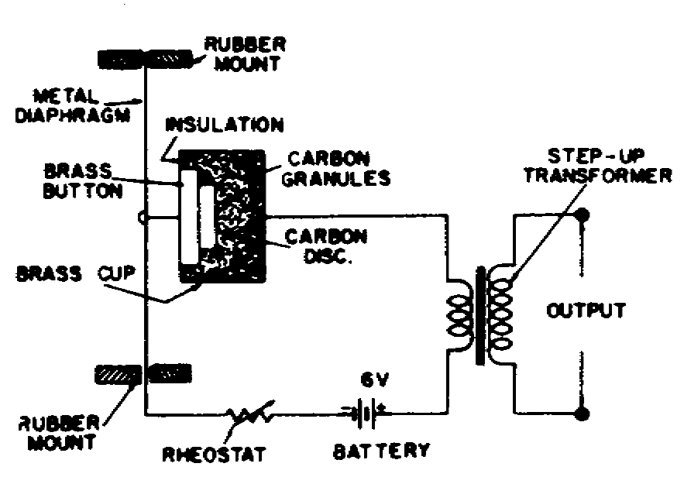

Figure 3-2. Connection and construction
of a single-button carbon microphone

(1) The output voltage from a carbon or pressure microphone is proportional to the displacement of the diaphragm.

(2) Figure 3-1 (1) shows the field pattern is omnidirectional.

(3) One of the principle disadvantages of the carbon microphone is that it has continuous high frequency hiss caused by the changing resistance between the carbon granules. In addition, the frequency is limited and the distortion is rather high.

6. What is a double button carbon microphone? The double-button employs two carbon buttons similar to those used in a single button microphone. One button is mounted on each side of the diaphragm. Pressure waves (or sound waves) striking the surface of the stretched diaphragm cause it to move, (or oscillate) disturbing the contact resistance of the carbon granules in the buttons similar to the action that happens within a single button carbon microphone.

a. As the diaphragm moves, the contact resistance in the granules of the button mounted on the pressure wave side is reduced, while the resistance of the button on the opposite side is increased.

b. When the pressure wave reverses itself, the reverse action takes place in the carbon buttons.

c. The current through the buttons corresponds to each half of the pressure wave at the diaphragm. This action is some what similar to the action of a push-pull amplifier stage. Figure 3-3 shows the circuit connections and construction.

25

Lesson 3/Learning Event 1

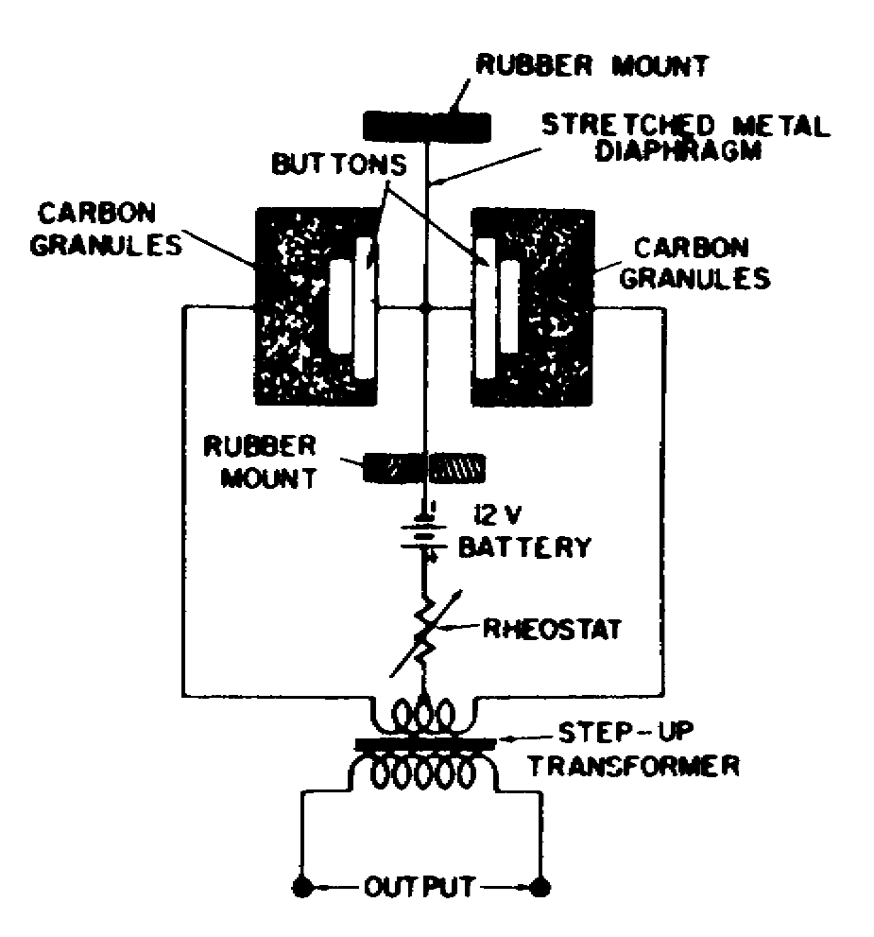

Figure 3-3. Connections and construction of a double-button carbon microphone

NOTE: Figure 3-4 shows the exterior appearance of an early double-button microphone

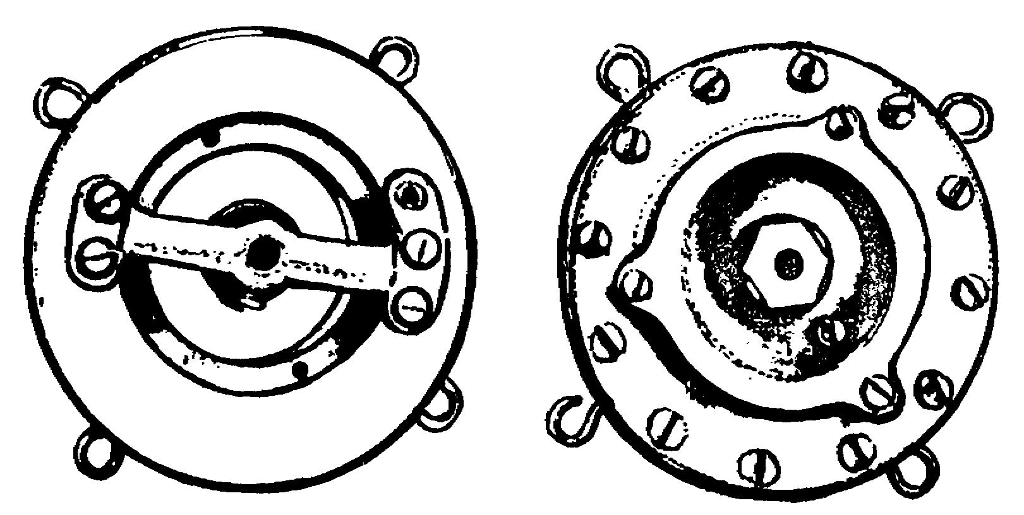

Figure 3-4. Early model Western Electric type 600A, double-button,
stretched-diaphragm, carbon microphone

d. The disadvantages for the double-button microphone are similar to those of a single-button microphone, except the waveform distortion is less. Figure 3-5 pictures the frequency responses for the single-button and double-button microphones.

26

Lesson 3/Learning Event 1

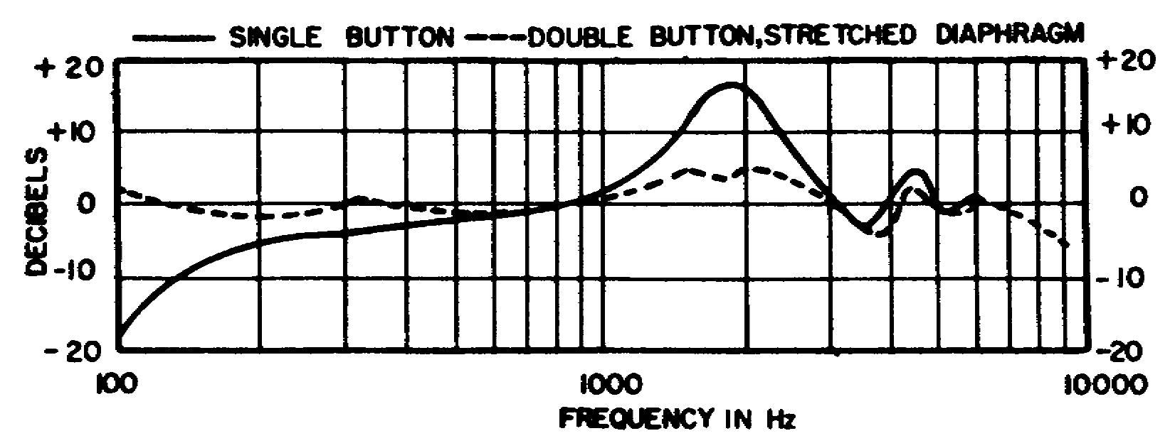

Figure 3-5. Frequency response of early model single-and,
double-button carbon microphones

7. What precautions should be observed when using carbon microphones? Current should be monitored to ensure that it does not exceed the specifications for a particular microphone; if it does, the carbon granules located in the button will be fused together and will render the microphone useless.

a. If the double button microphone is being used, the current through each button should be the same when the diaphragm is at rest.

b. Carbon microphones should not be subjected to jarring while current is flowing, unless they are designed for heavy duty use.

27

Learning Event 2:
DESCRIBE USES AND OPERATION OF THE CERAMIC AND DYNAMIC MICROPHONES

1. Ceramic Microphones. Ceramic microphones are, characteristically, a sturdy instrument. This microphone is used in conjunction with walkie talkies, dictating machines and public address systems. The ceramic microphone is widely used in areas of high temperature and high humidity. The impedance of this type of microphone is normally 1 to 5 megahoms.

2. Dynamic Microphones. This type of microphone employs a small diaphragm and a voice coil, similar to a dynamic loudspeaker, moving in an intense permanent magnetic field.

a. Sound waves striking the coil cause it to move within the magnetic field, generating a voltage proportional to the sound pressure exerted on the diaphragm. This microphone is also referred to as a pressure, or moving coil, microphone; typical examples of this design are shown in Figures 3-6a and 3-6b.

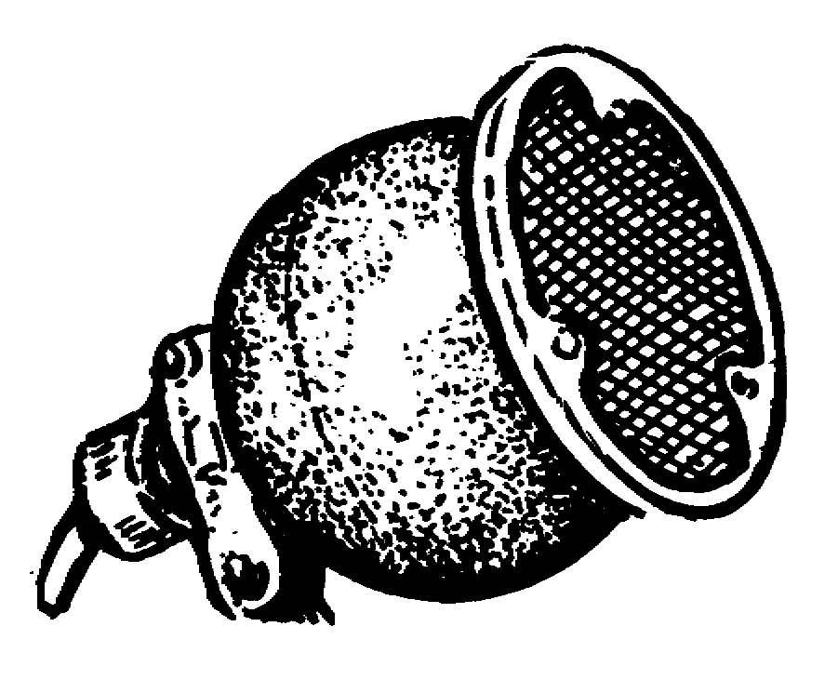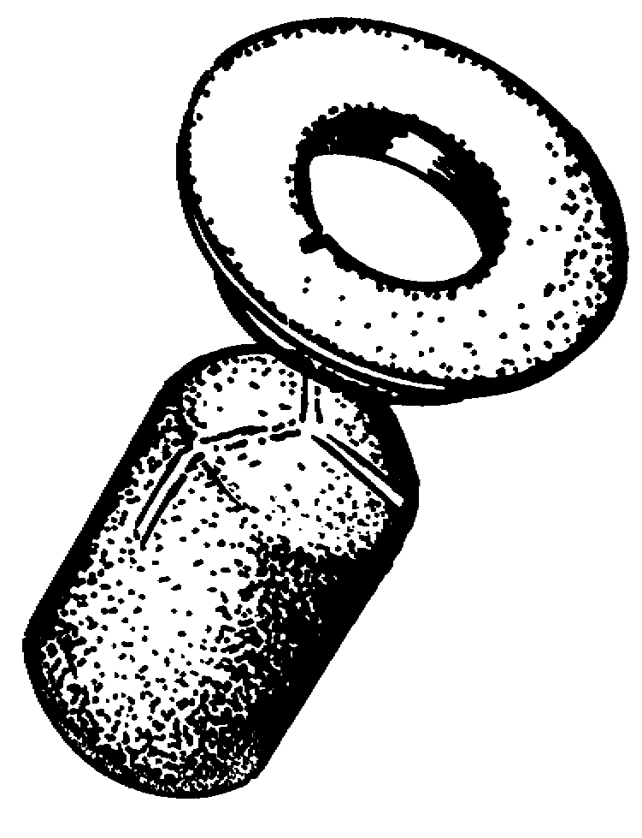

Figure 3-6a. Western Electric Figure 3-6b. Altec-lansing
630B dynamic (moving-coil) Model 633a/c dynamic (moving-
microphone coil) microphone

b. Figure 3-7 shows a cross section view of the 630B microphone. The diaphragm (A) is of Dural, approximately 0.5 mils in thickness, and weighs 25 milligrams. Cemented to the rear of the diaphragm is a voice coil (B).

28

c. The body of the microphone (C) consists of a molded spherical housing containing a permanent magnet (D) with a center pole piece over which the voice coil is centered. The edge of the diaphragm is hinged and supported at the edges by the housing. The outer surface of the diaphragm is protected from damage by perforated grid (E).

d. A two-layer circular mesh screen baffle, (F), with layers of silk between the screens, is placed in front of the diaphragm.

e. The perforated grid and screen act as acoustical equalizers to improve the omnidirectional characteristics.

f. At the lower left is a small metal tube (G) termed an acoustical equalizer. Its function is to release air pressure behind the diaphragm to prevent distortion of the diaphragm during its inward travel.

g. Working in conjunction with this tube are two air-release vents (H) under the voice coil to provide acoustical resistance. External pins (I) provide connections to the voice coil lead (J).

h. The (L) baffle is used to assist in achieving a directional characteristic.

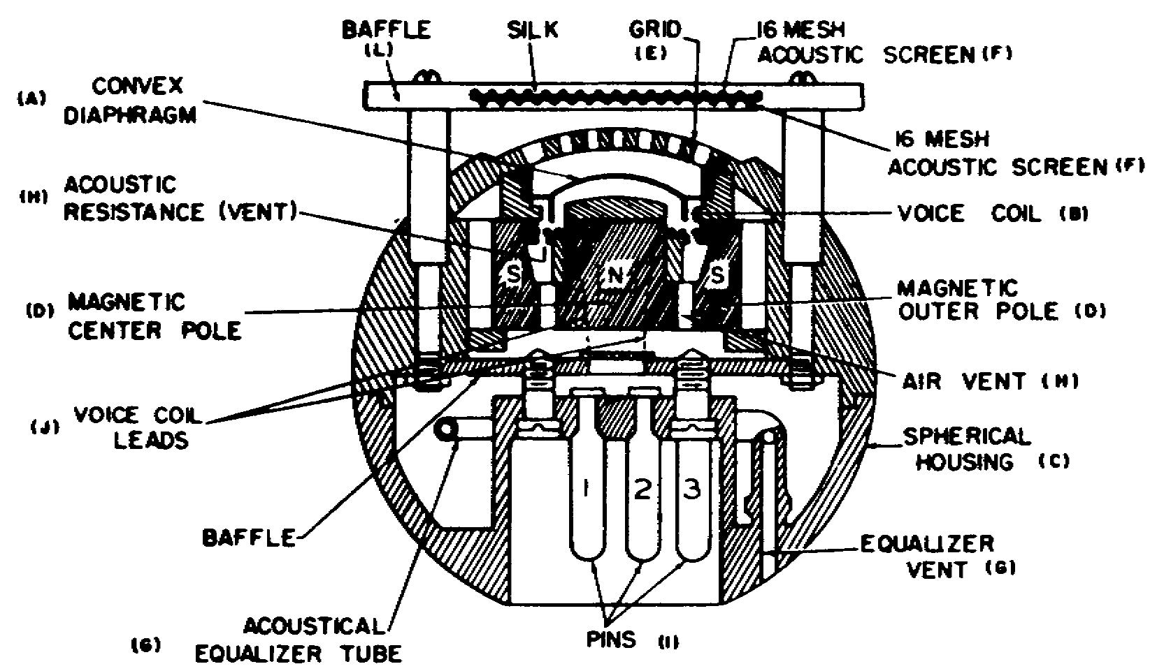

Figure 3-7. Cross-sectional view of Western Electric 620B

3. Microphones of the above type do not employ an output transformer. The output voltage is taken directly from the voice coil winding. The frequency of the microphone is little affected by the angle of incidence up to 120 degrees (fig 3-8). The impedance of this microphone is 20 ohms, but is operated into a 30 to 50 ohm preamplifier.

29

Lesson 3/Learning Event 2

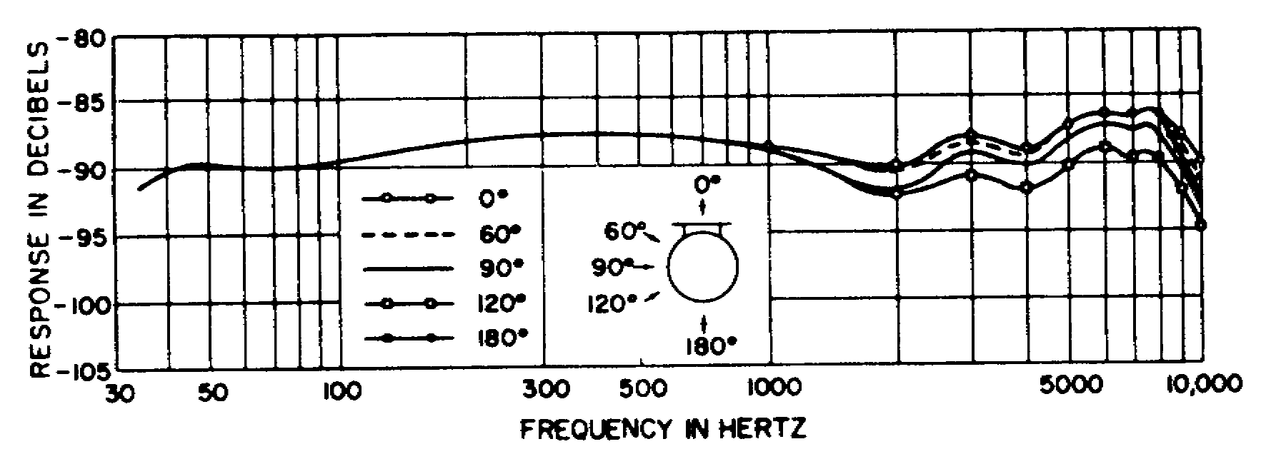

Figure 3-8. Frequency characteristics of Western Electric dynamic
(moving-coil) microphone for different angles of incidence

30

Learning Event 3:
DESCRIBE USES AND OPERATION OF THE CARDIOID MICROPHONE

1. Cardioid Microphone. Both television and motion picture productions have suffered greatly from the fact that in order to pick up good sound, the microphone must be reasonably close to the talent. On a television set this causes difficulties for both the camera person and the sound person. These problems have been overcome by the development and introduction of the cardioid in-line directional microphone.

a. Two of the most important characteristics of any microphone are its sensitivity and directional qualities.

b. Assuming a constant sound pressure source, increasing the distance of the microphone from the source requires an increase in the gain of the amplifying system after the microphone. This is accompanied by a decrease in signal to noise ratio and an increase in environmental noises, such as reverberation and background noise, to where the indirect sound may equal the direct sound. In other words, the pickup deteriorates to where it is unusable.

c. Distance limitations can be overcome by increasing the sensitivity of the microphone, and the effect of reverberation can be lessened by increasing the directivity of the pattern. The in-line microphone has these two desirable qualities.

2. Over the years the most commonly used microphone for boom operation and the recording dialogue has been a gradient microphone with a cardioid directional polar pattern, (fig 3-1).

a. In addition to the polar plot, the directional characteristics of a microphone may be described as a ratio termed directive index. Directivity index is a ratio of output voltage from a microphone in a sound field that arrives at the microphone from all directions, to the output voltage of an omnidirectional microphone, with equal sensitivity, in the same sound field.

b. The directivity index is a measure of nonaxial response; the lower the directivity index the sharper the polar response.

3. For microphones of the bidirectional and cardioid type, the index is 3 to 1; because of baffle effects, the polar response becomes narrower at higher frequencies.

a. Figure 3-9 shows a graphical plot of the directivity index versus frequency response for an 11-inch cardioid in-line microphone, and for a 1.5-inch dynamic gradient microphone with a cardioid polar pattern curves A and B.

31

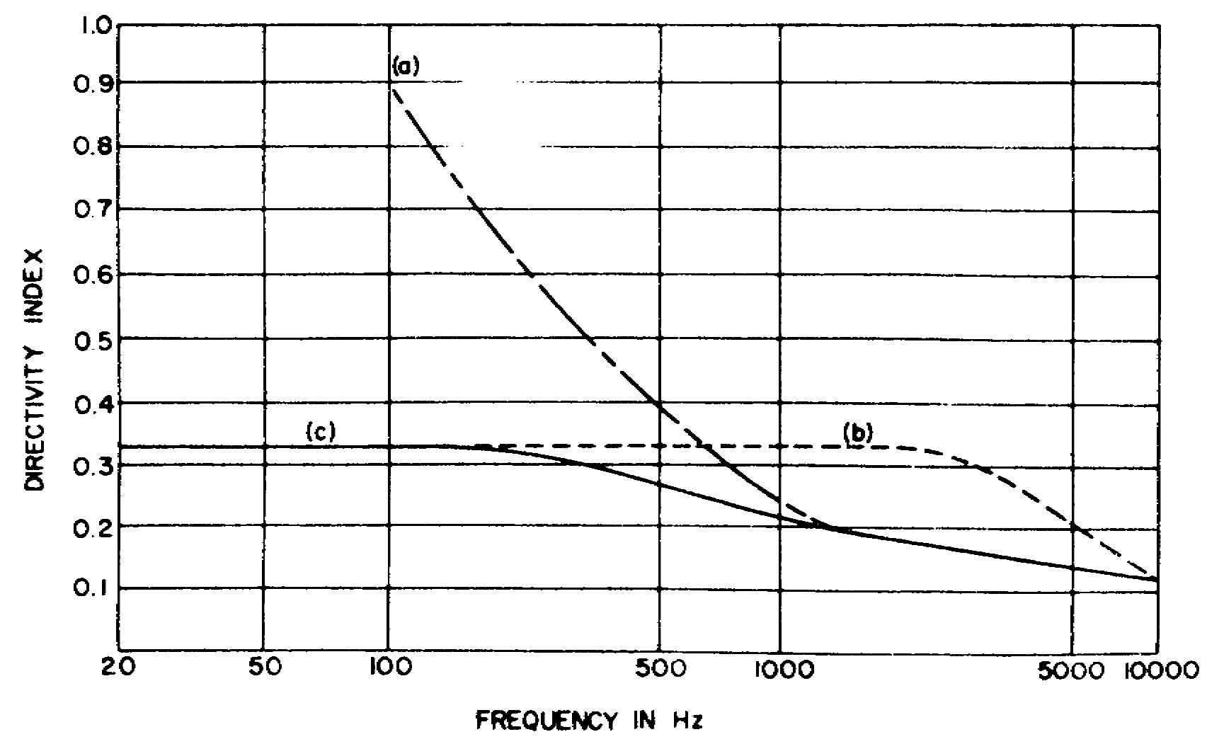

Figure 3-9. Directivity index for: (a) 11-inch line microphone, (b) cardioid
microphone, (c) Electro-Voice Model 642 Cardline of dynamic microphone

b. Figure 3-10 shows the basic components of this microphone. In-line tube (A) has a 1/8-inch slot milled its entire length and a group of ports which act as a linear tapering acoustic resistance. In-line tubes are equally sensitive to equal sound pressures, and will cause equal voltages to be generated at the output of the dynamic transducer unit (C).

32

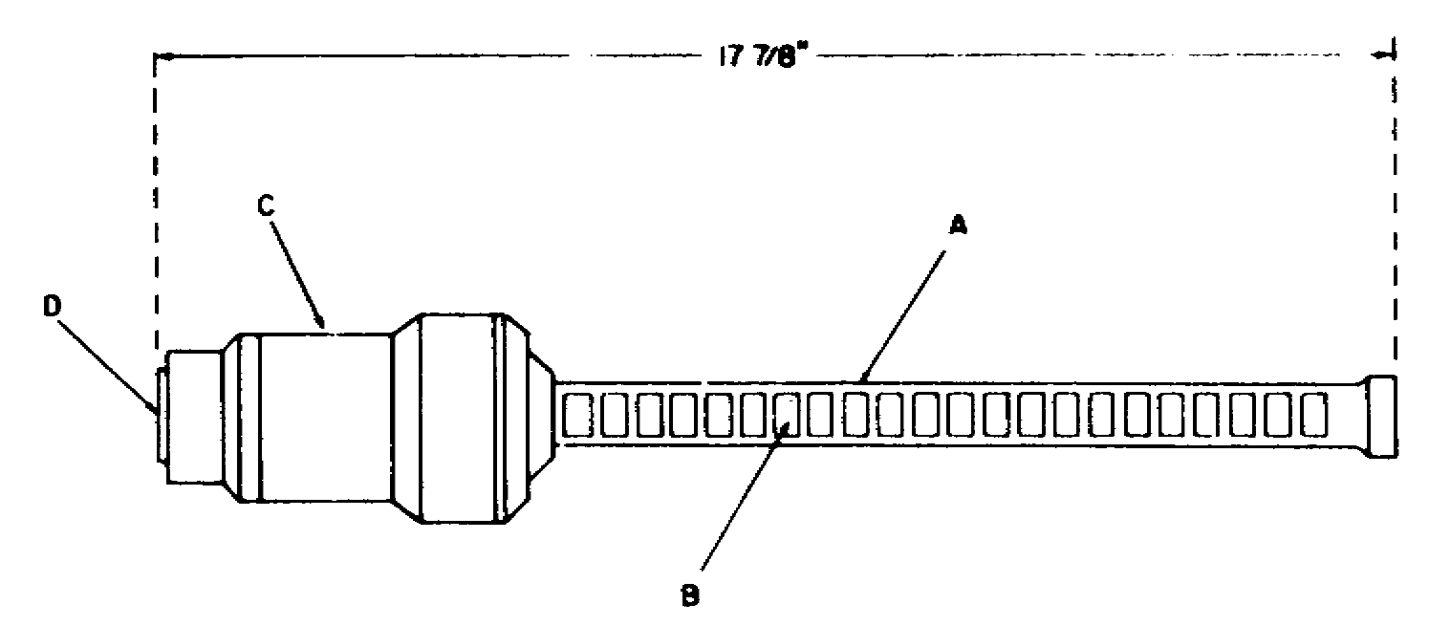

Figure 3-10. Basic components of the Electro-Voice Model 642
Card line directional microphone

c. Since the ports are equally connected to the transducer unit by the common tube, acoustic delays are introduced ahead of the transducer element.

d. When placed in a plain wave sound field, this equal sensitive line with variable delay produces wave interference in the common cavity at the front of the transducer unit.

e. The magnitude of the interference will depend on the angle between the plain wave and the axis of the tube. The directivity of a line microphone is a function of frequency; the lower the frequency, the broader the polar pattern (fig 3-11).

33

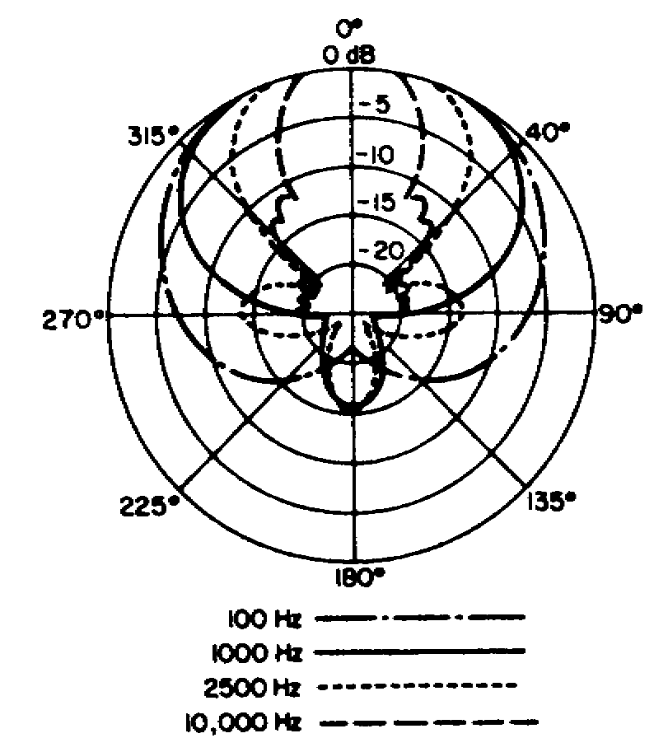

Figure 3-11. Polar response pattern for Electro-Voice Model 642
Cardline directional in-line microphone

4. Sensitivity is achieved by a rather heavy magnetic structure consisting of an Indox 5 and Armco magnetic iron core, approximately 2 1/2 inches in diameter.

a. Dimensions of this size can be used because of the size of the in-line tube; no baffle effects occur, thus directivity is controlled by the openings in the tube structure.

b. The diaphragm of the dynamic unit is 1 1/4 inch in diameter with a 3/4- by 1 1/4-inch voice coil.

34

PRACTICE EXERCISE

1. What are two categories of microphone operation?

a. Carbon and condenser c. Ribbon and dynamic
b. Pressure and velocity d. Dynamic and carbon

2. What happens to pressure microphones when the input frequency is lowered?

a. They become nondirectional
b. They become highly directional
c. They need an external voltage
d. They become useless

3. What is another name for a velocity microphone?

a. Sinusoidal microphone c. Gradient microphone
b. DC-powered microphone d. Remote microphone

4. What type of microphone uses a figure-eight polar pattern?

a. Ribbon microphone c. Crystal microphone
b. HaLstead microphone

5. What contains carbon granules?

a. Plastic coating c. Glass
b. Button

6. In which operational category does a carbon microphone belong?

a. Velocity c. Retroactive
b. Pressure d. Battery-powered

7. What type of polar pattern does a carbon microphone use?

a. Bidirectional c. Omnidirectional
b. Solodirectional d. Directional

8. What term may be used in place of polar pattern?

a. Square pattern c. Para pattern
b. Round pattern d. Field pattern

9. Which of the carbon microphones produce the most distortion?

a. Triple-button c. Single-button
b. Double-button

35

10. What is the impedance of a ceramic microphone?

a. High c. Moderate
b. Low

11. Ceramic microphones are widely used in what type of climate?

a. Dry, hot climate c. Humid, dry climate
b. Wet, cold climate d. Hot and humid climate

12. What is accomplished by the perforated grid and screen on a dynamic micro-phone?

a. Acoustical equalization
b. Omindirectional characteristics
c. Acoustical equalization and omnidirectional characteristics

13. What is the impedance of a dynamic microphone?

a. Low c. High
b. Moderate

14. Which type of microphone allows the talent to be most distant from the microphone?

a. Carbon microphone
b. Cardioid in-line microphone
c. Condenser microphone

15. What does the directivity index inform you of?

a. Current c. Ratio in to out
b. Sound

16. The line tube in a cardioid microphone performs what function?

a. Equal output voltages to the transducer
b. Unequal current output to the transducer
c. Eliminates hum

17. How do you broaden the polar pattern of an in-line cardioid microphone?

a. Raise the frequency c. Change air flow
b. Lower the frequency

36

ANSWERS TO PRACTICE EXERCISES FOR LESSON 3

1. B
2. A
3. C
4. A
5. B
6. B
7. C
8. D
9. B
10. A
11. D
12. C
13. A
14. B
15. C
16. A
17. B

37

GLOSSARY

line drive an intermediate amplifier with normal amplification characteristics

video amplifier a wide ban amplifier that increases the video level to an acceptable amplitude required by the following stage

attenuator introduces resistance in a circuit to reduce overall signal levels

fixed gain a certain resistance incorporated in a voltage path. With a stable input voltage and the fixed resistance, the output voltage to the next stage will always remain fixed at the required level

high sensitivity circuit an active attenuation circuit

low sensitivity circuit a passive attenuation circuit

preamplifier very stable, its main function is the creation of a very high signal to noise ratio

sawtooth waveform gets its name from its resemblance to a sawblade, is used to turn on an electronic device for a specific time period

CCU camera control unit located in the master control room, provides base voltages, video processing, synchronization, and interfaces the camera head with control room equipment

horizontal deflection deflects the electron beam within a cathode ray tube or a pickup tube through the use of horizontal deflection coils that are driven by a sawtooth waveform

retrace the return of the electron beam to the starting point in a cathode ray tube after completion of all or a part of the scanning process (flyback)

height control used to vary the amplitude of the signal sent to the vertical deflection section

dynamic transducer has a movable coil mounted in a magnetic field. Air pressure causes the coil to vibrate within the magnetic field, thus causing an induced voltage

interlaced scanning television scanning in which each frame is scanned in two successive fields each consisting of all the odd or all the even horizontal lines.

38

FULL PAGE FOLDOUTS

Figure 1-1 (fo). Camera head portion of
video system, block dia

Figure 1-2 (fo). Pb0 pickup tube, operate
and control system, block dia

Figure 1-4 (fo). Video amplifier B module
block dia

Figure 2-1 (fo). Horizontal deflection
system, block dia

Figure 2-3 (fo). Vertical deflection
system, block dia

Figure 2-4 (fo). Deflection failure
protection system, block dia

Figure 2-5 (fo). Camera head DC power
system, block dia

Figure 2-6 (fo). AC power
system, block dia

44

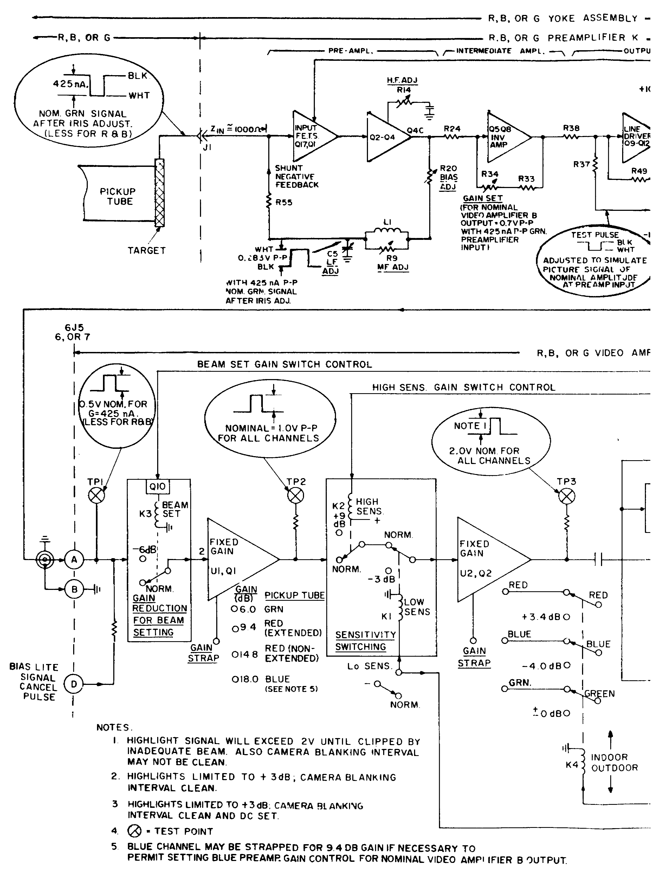

Figure 1-1 (fo). Camera head portion of video system, block dia

45

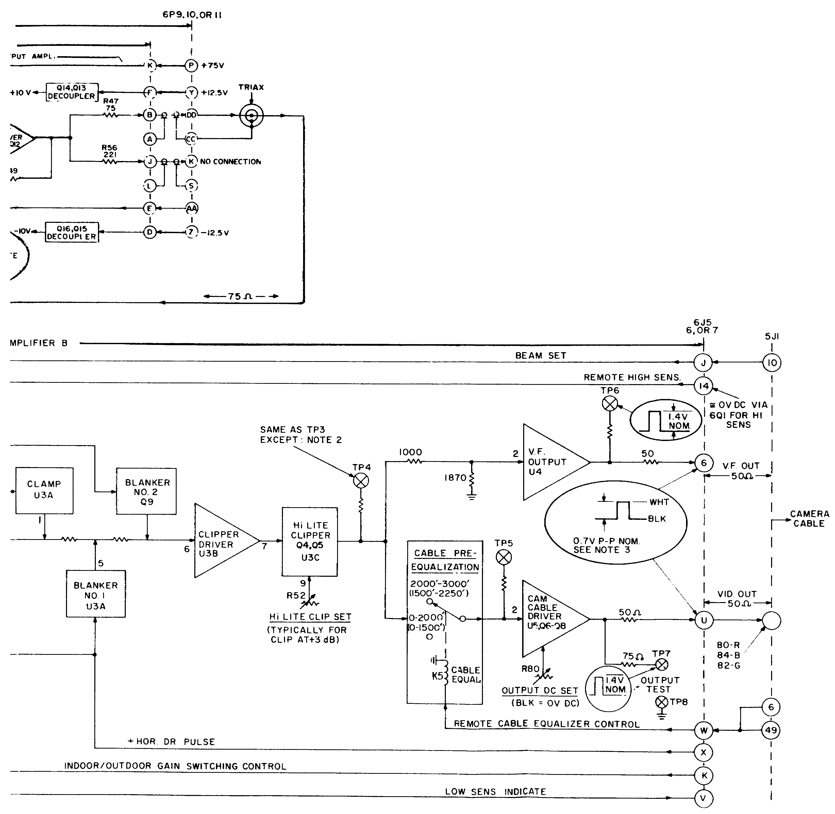

Figure 1-1 (fo). Camera head portion of video system, block dia

45A

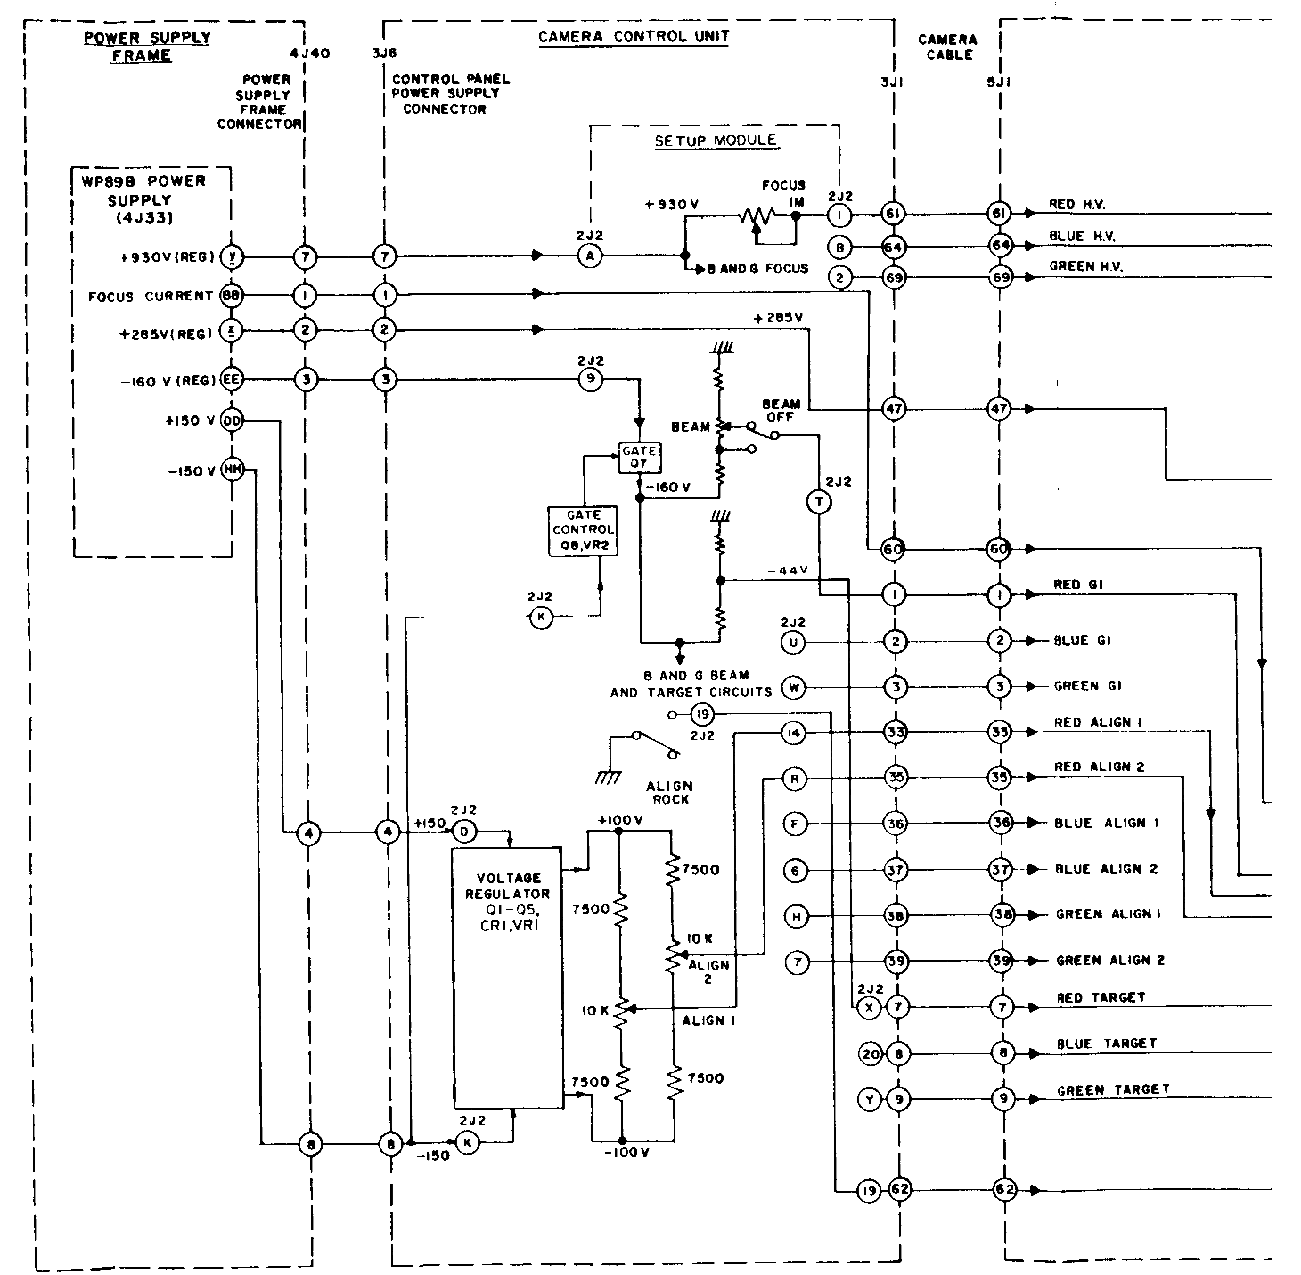

Figure 1-2 (fo). Pb0 pickup tube, operate and control system, block dia

47

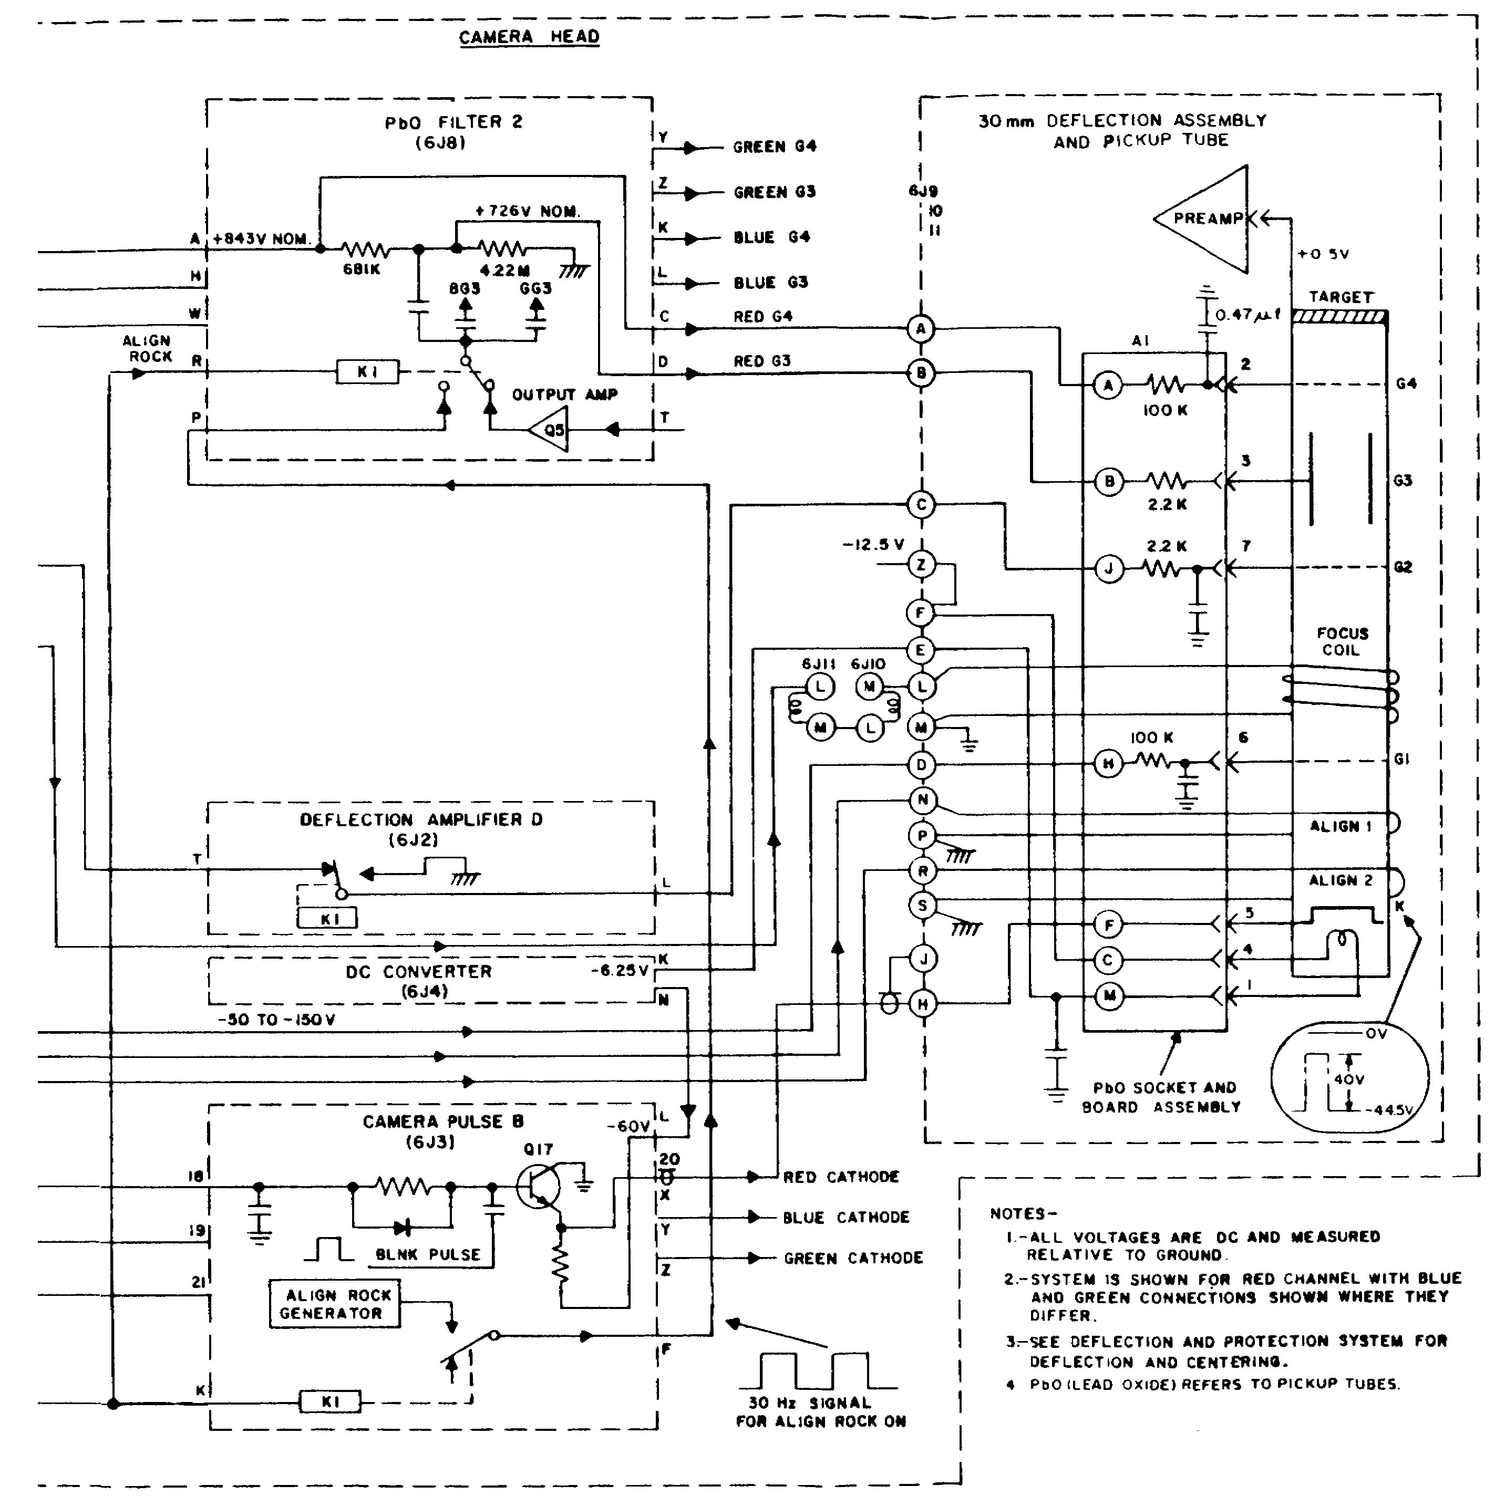

Figure 1-2 (fo). Pb0 pickup tube, operate and control system, block dia

47A

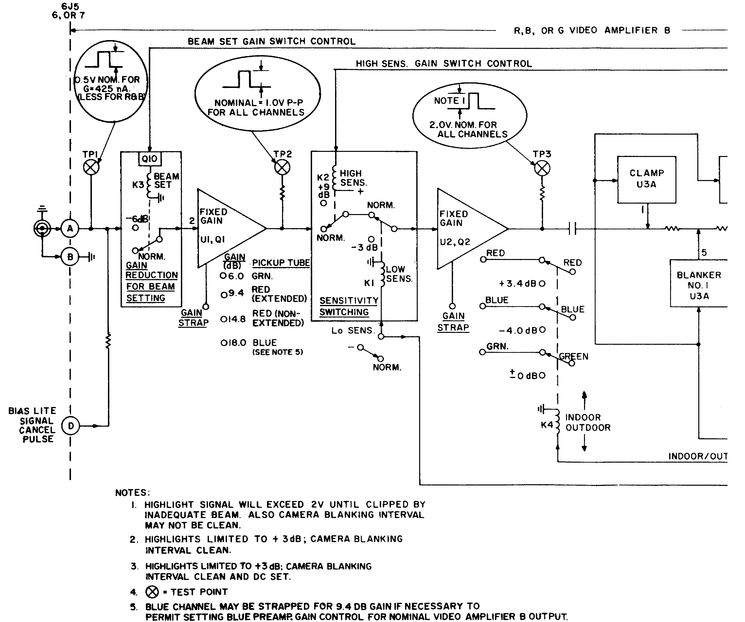

Figure 1-4 (fo). Video amplifier B module block dia

49

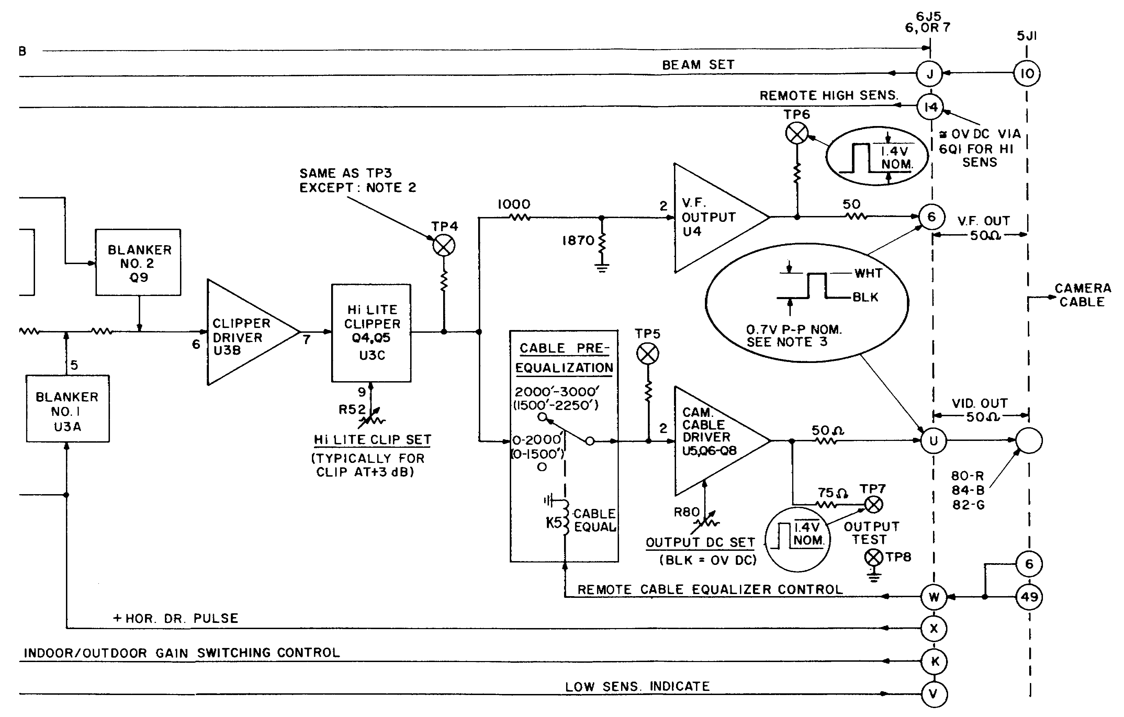

Figure 1-4 (fo). Video amplifier B module block dia

49A

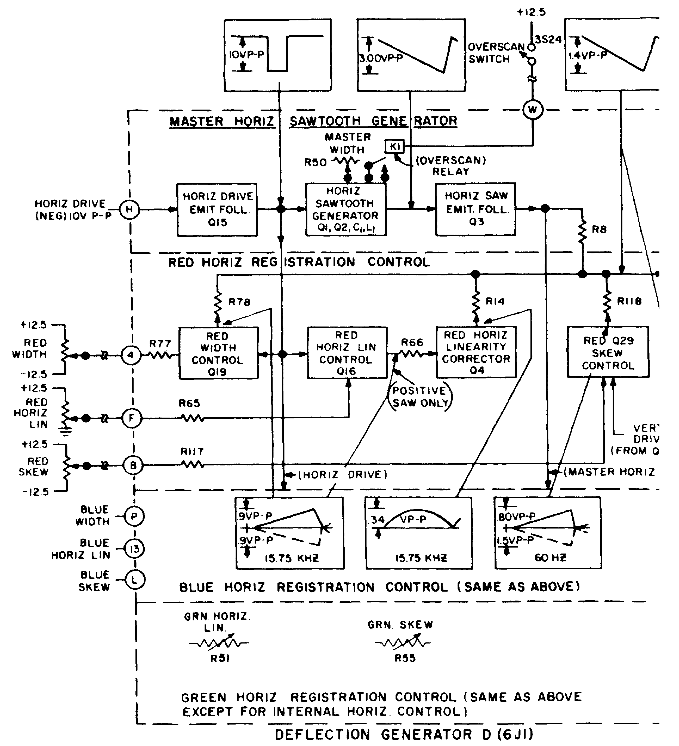

Figure 2-1 (fo). Horizontal deflection system, block dia

51

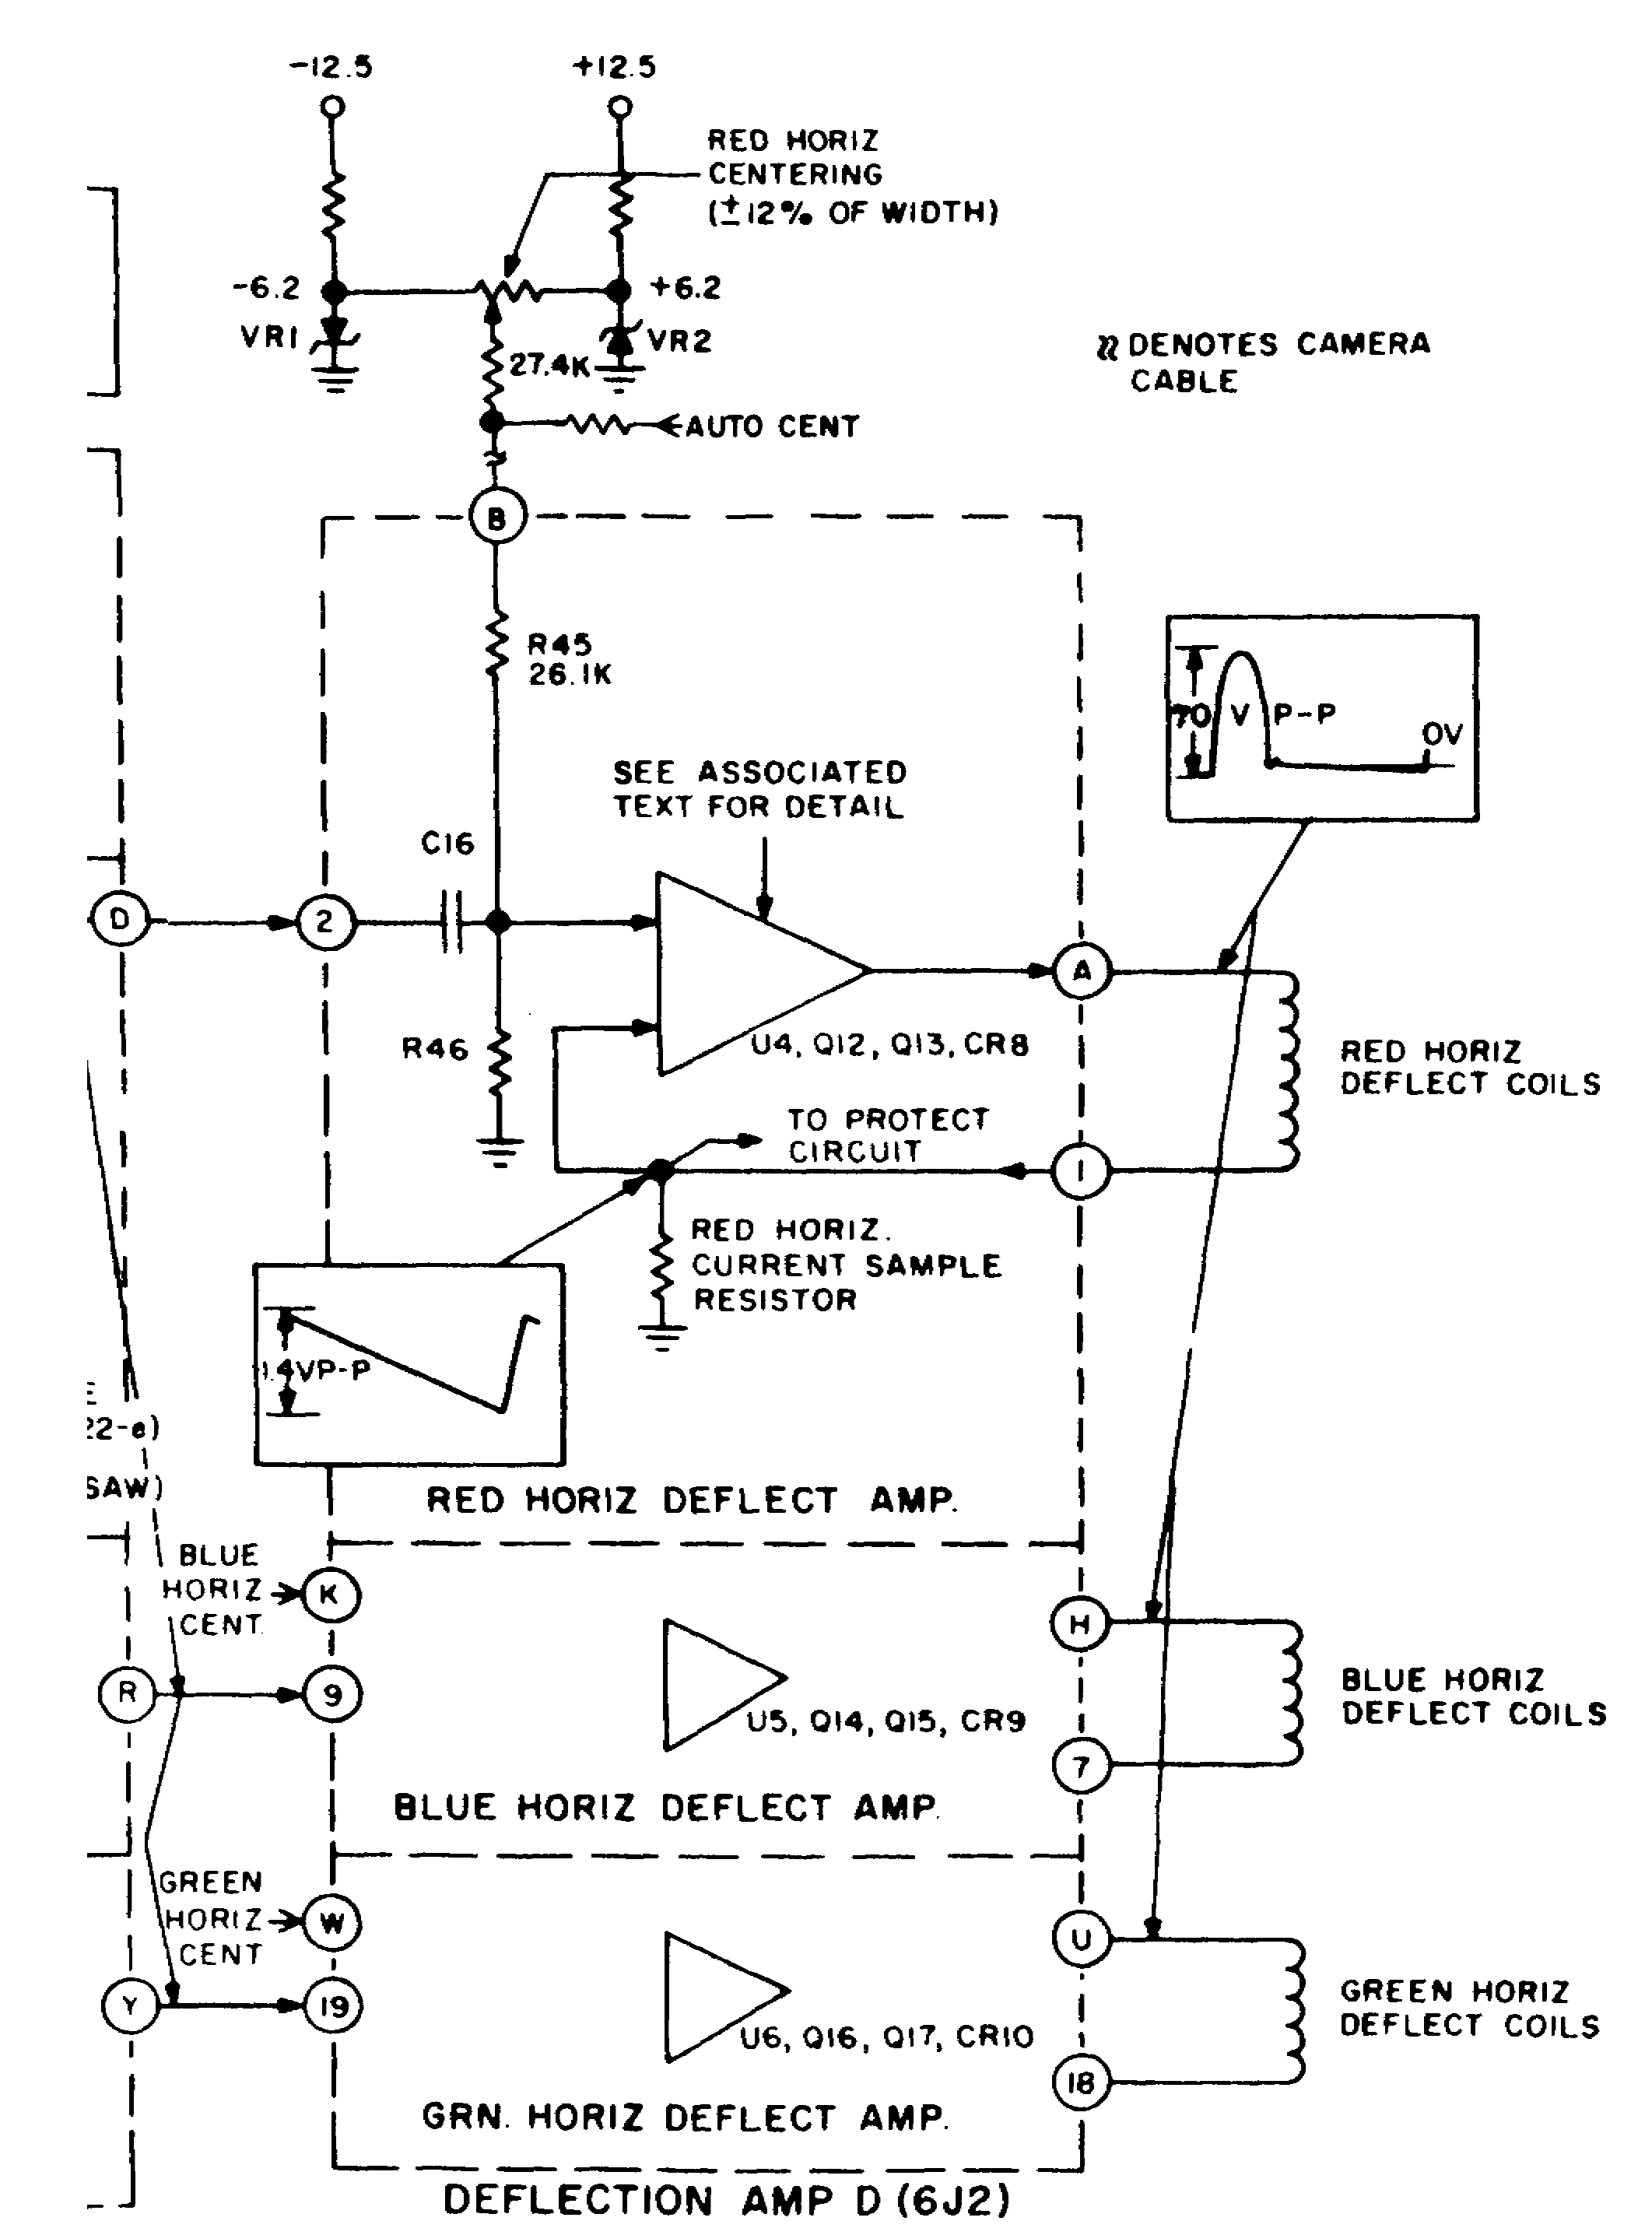

Figure 2-1 (fo). Horizontal deflection system, block dia

51A

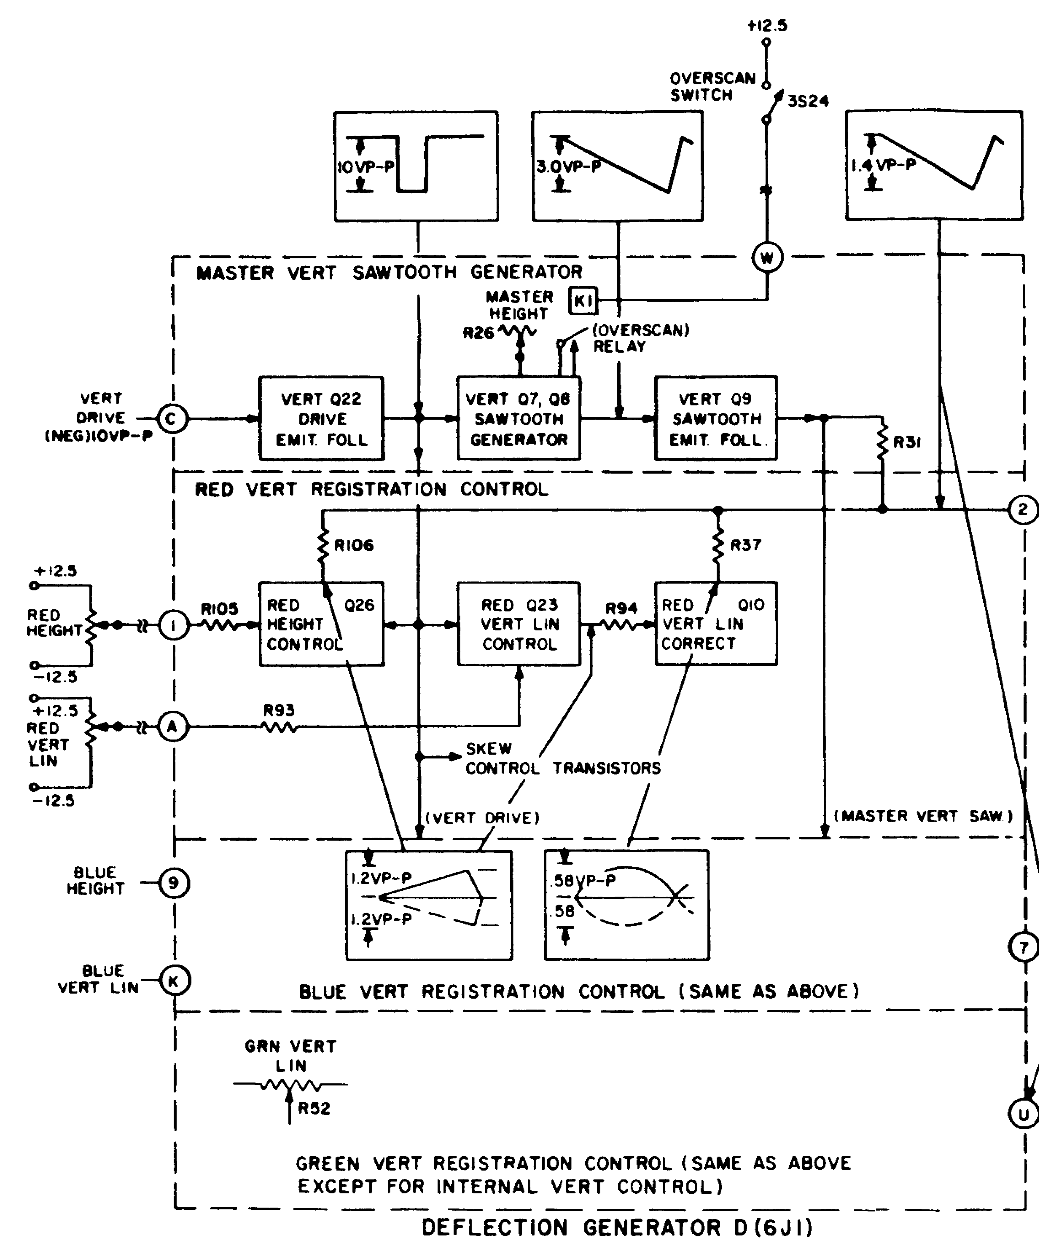

Figure 2-3 (fo). Vertical deflection system, block dia

53

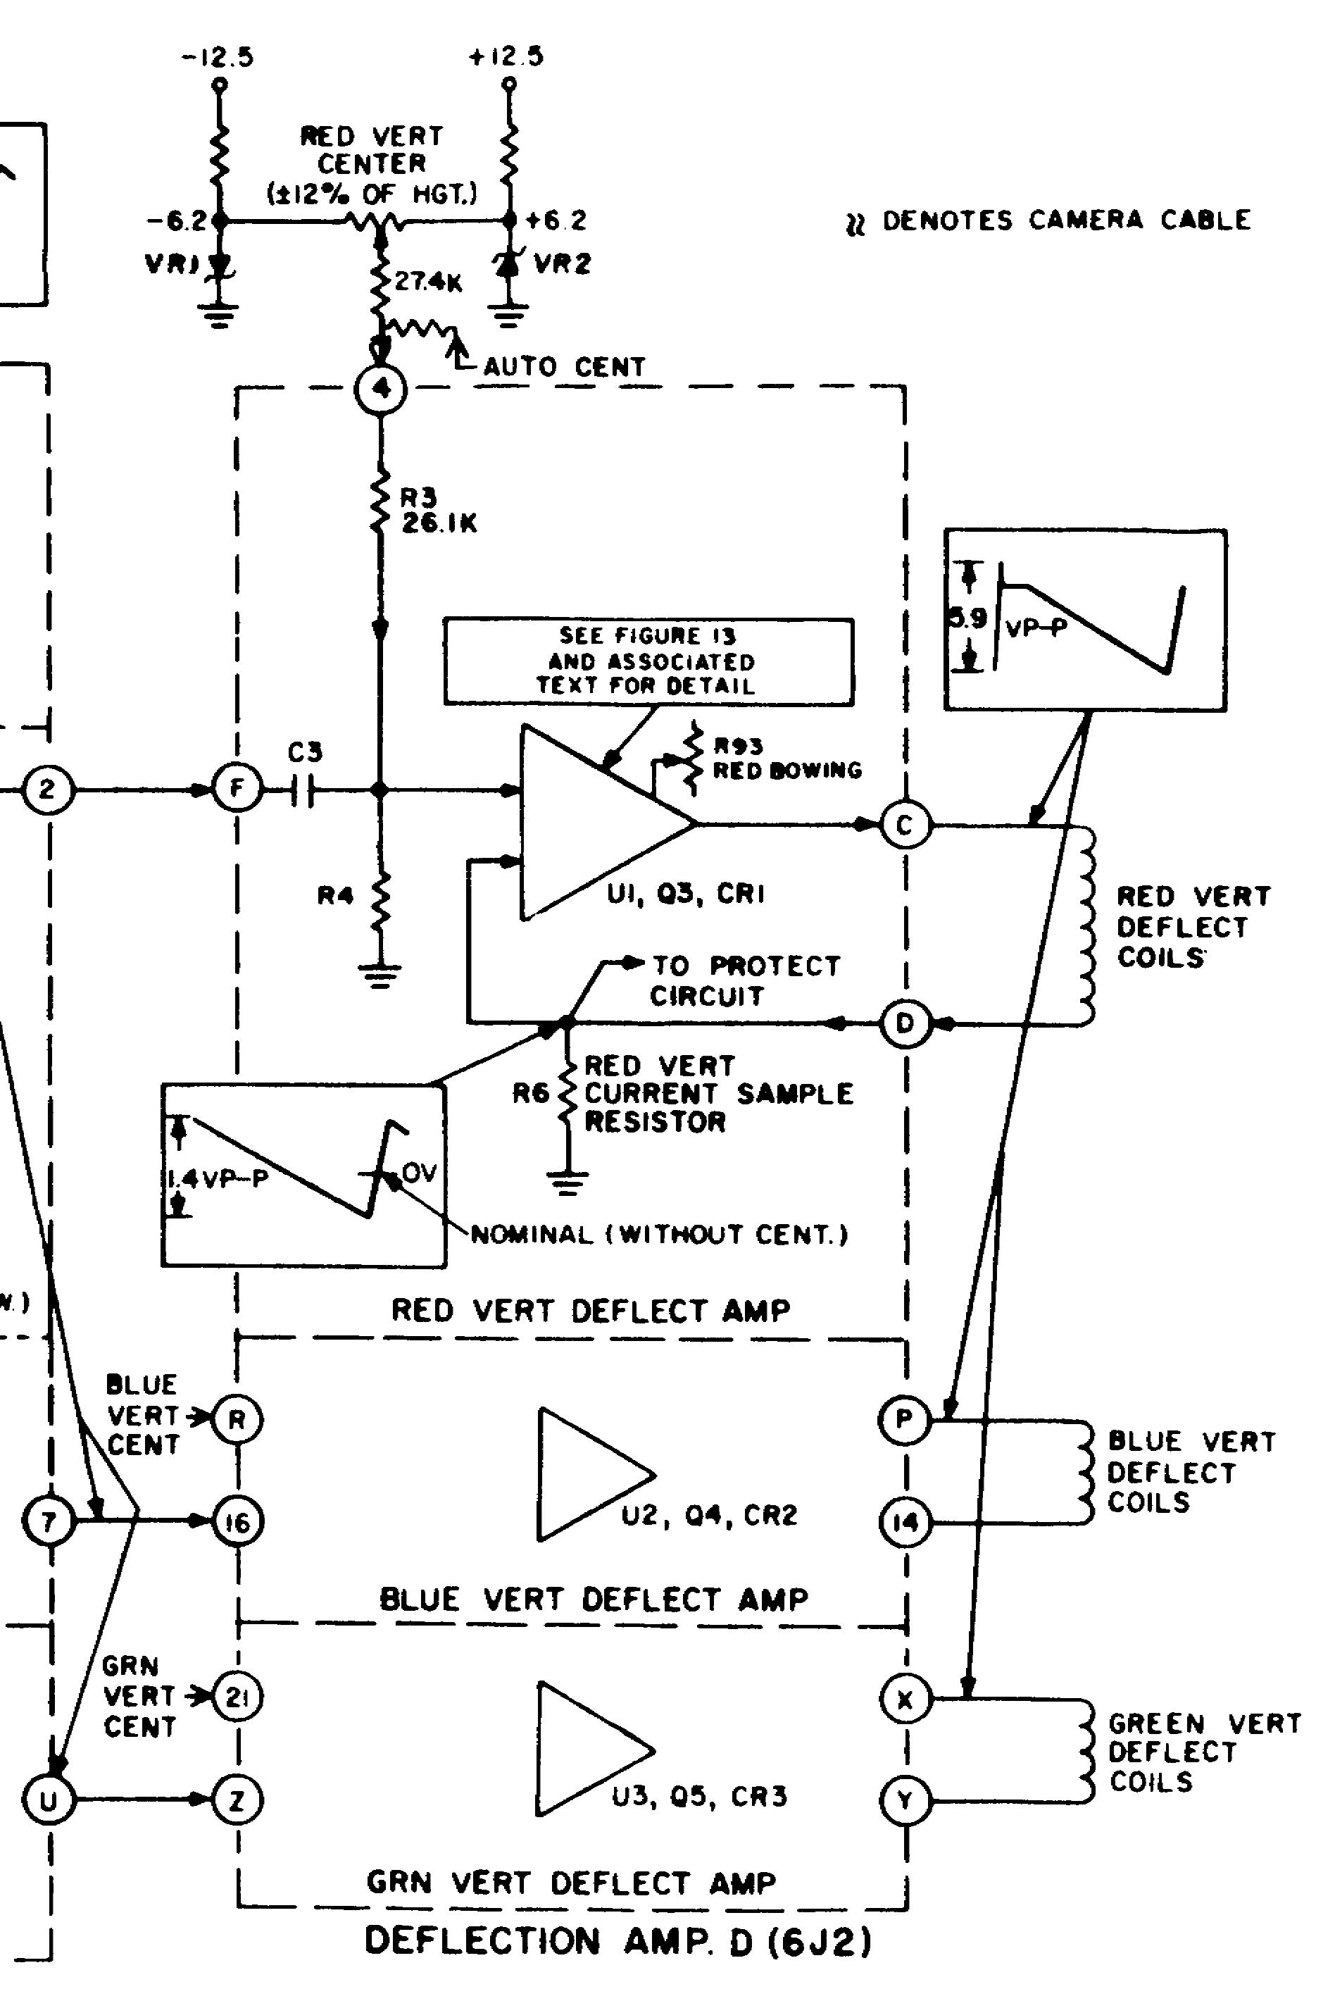

Figure 2-3 (fo). Vertical deflection system, block dia

53A

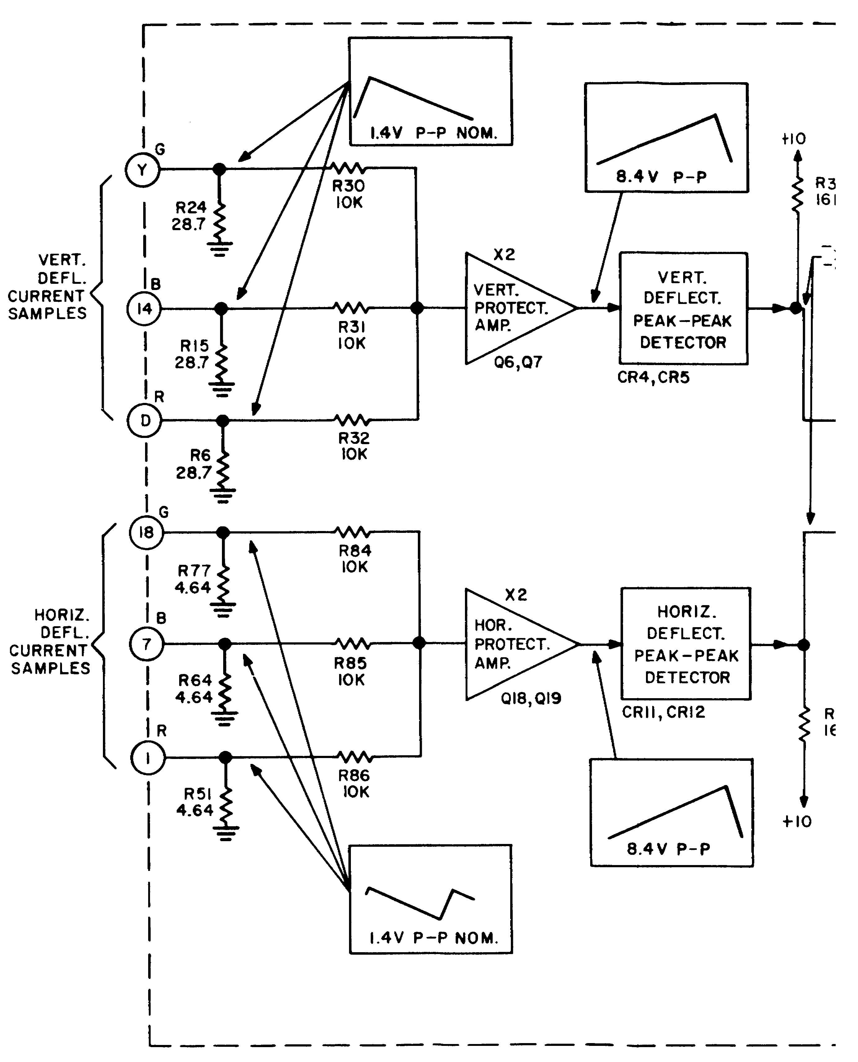

Figure 2-4 (fo). Deflection failure protection system, block dia

55

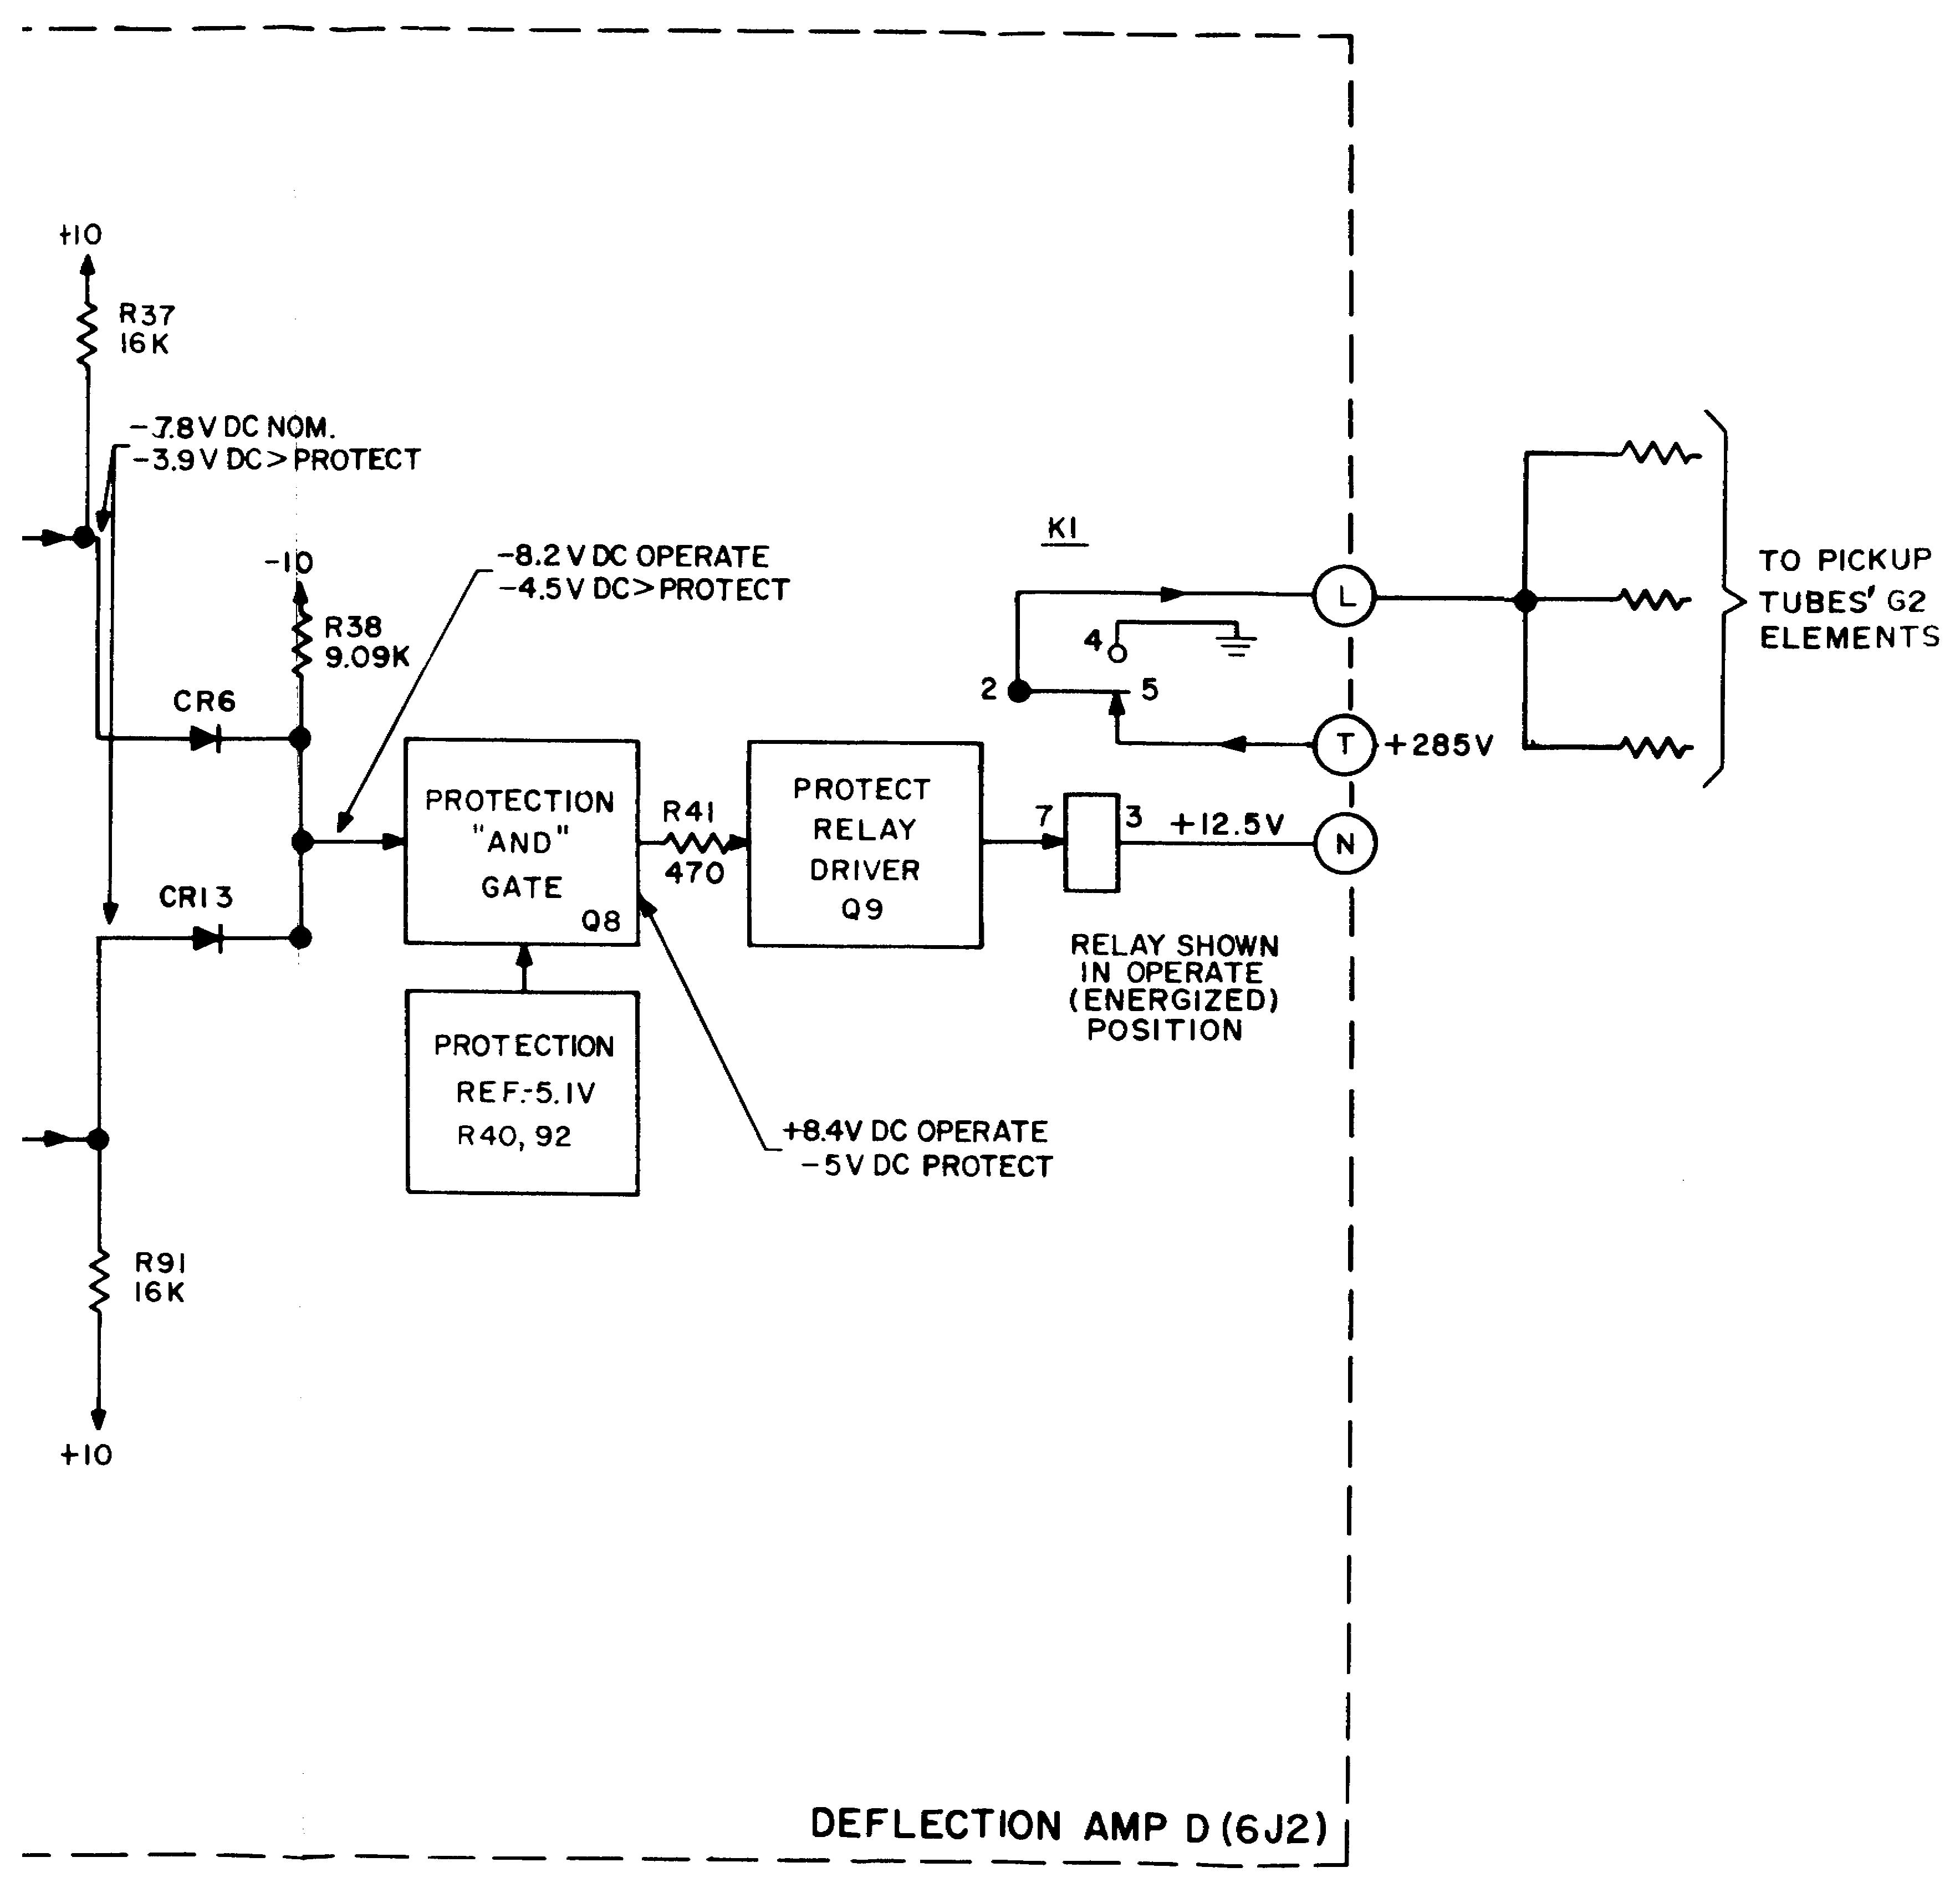

Figure 2-4 (fo). Deflection failure protection system, block dia

55A

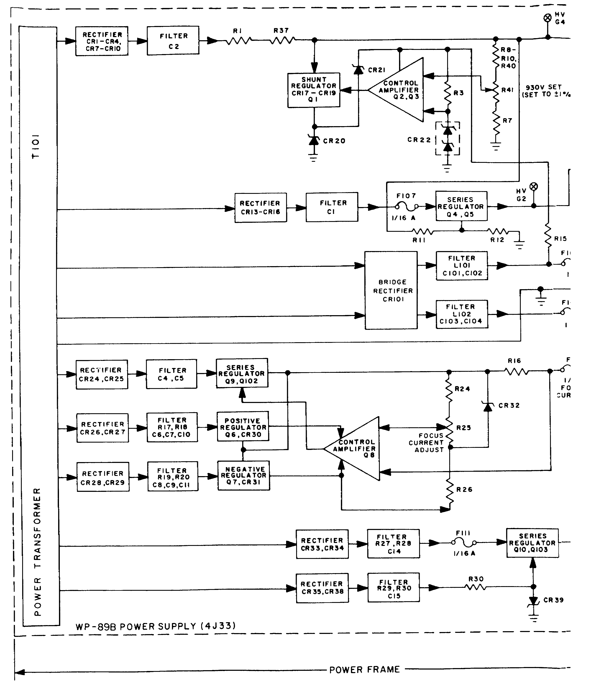

Figure 2-5 (fo). Camera head DC power system, block dia

57

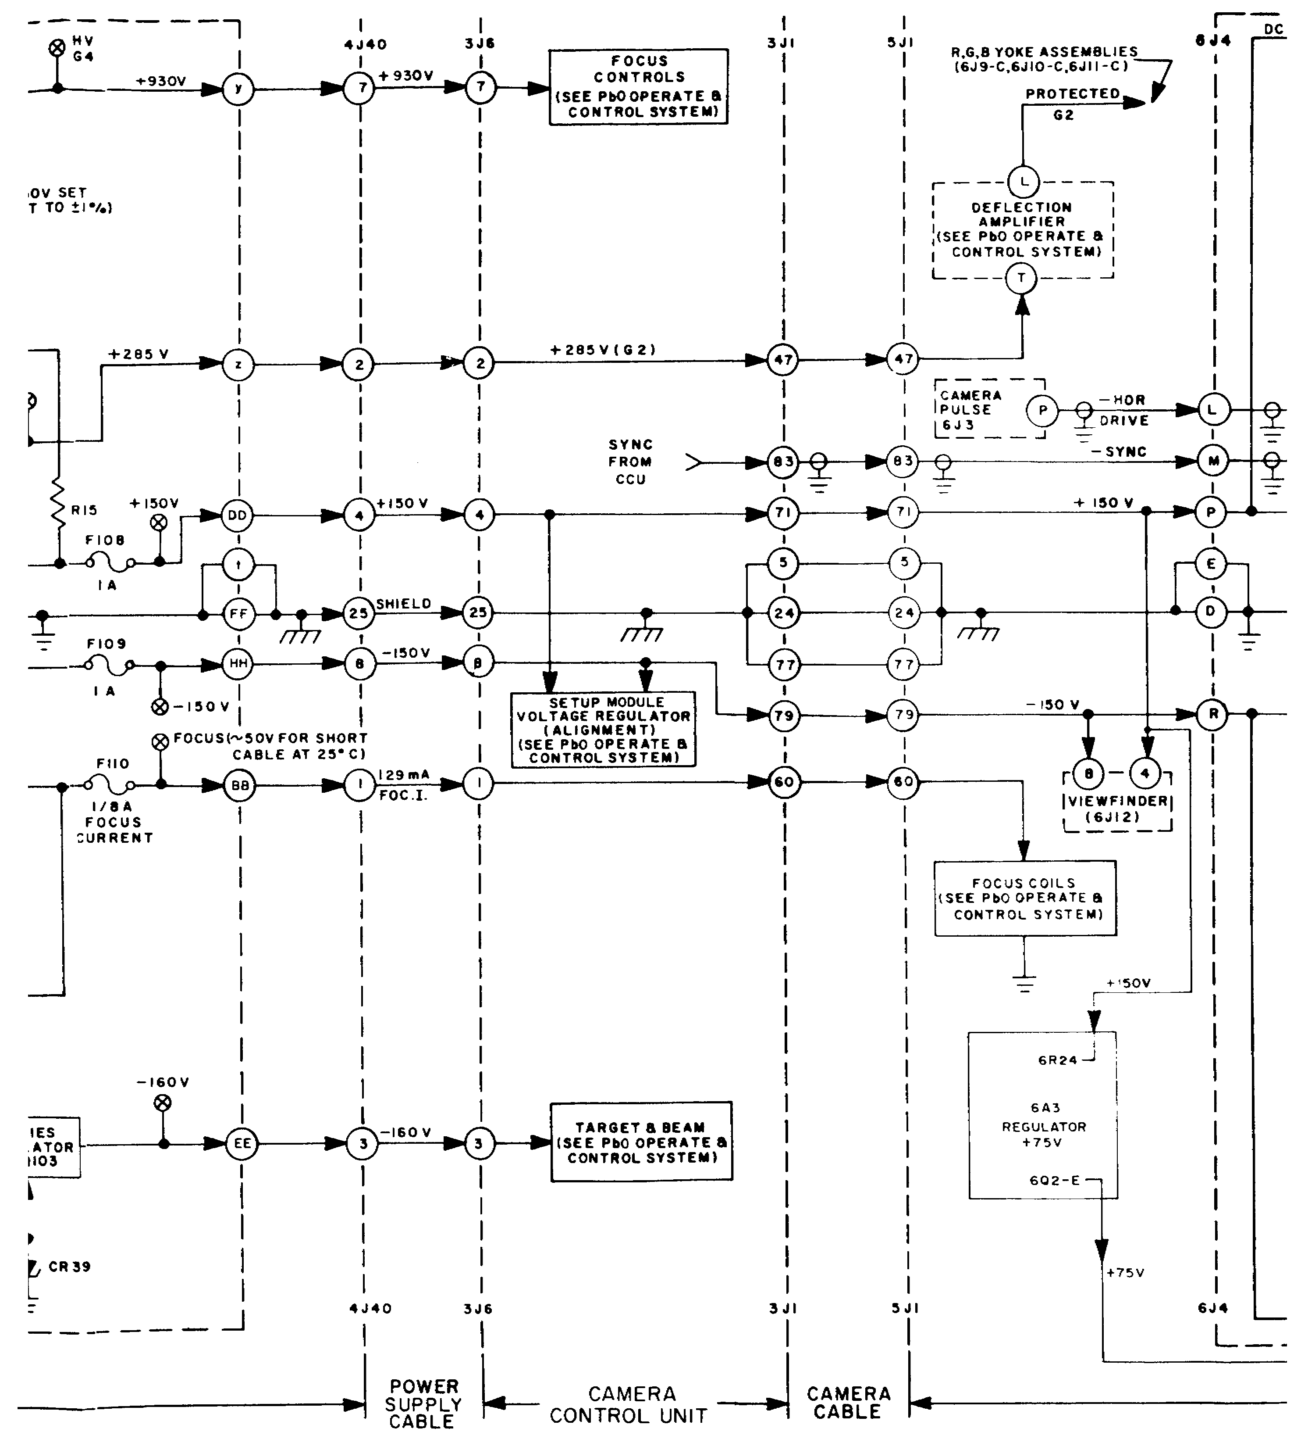

Figure 2-5 (fo). Camera head DC power system, block dia

57A

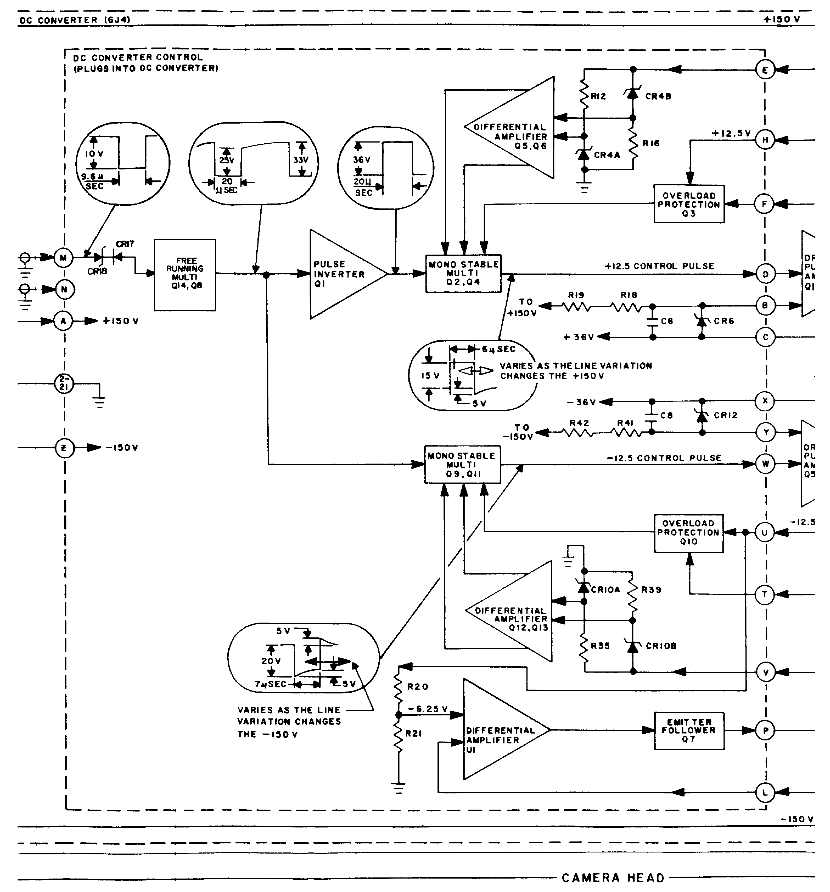

Figure 2-5 (fo). Camera head DC power system, block dia

57B

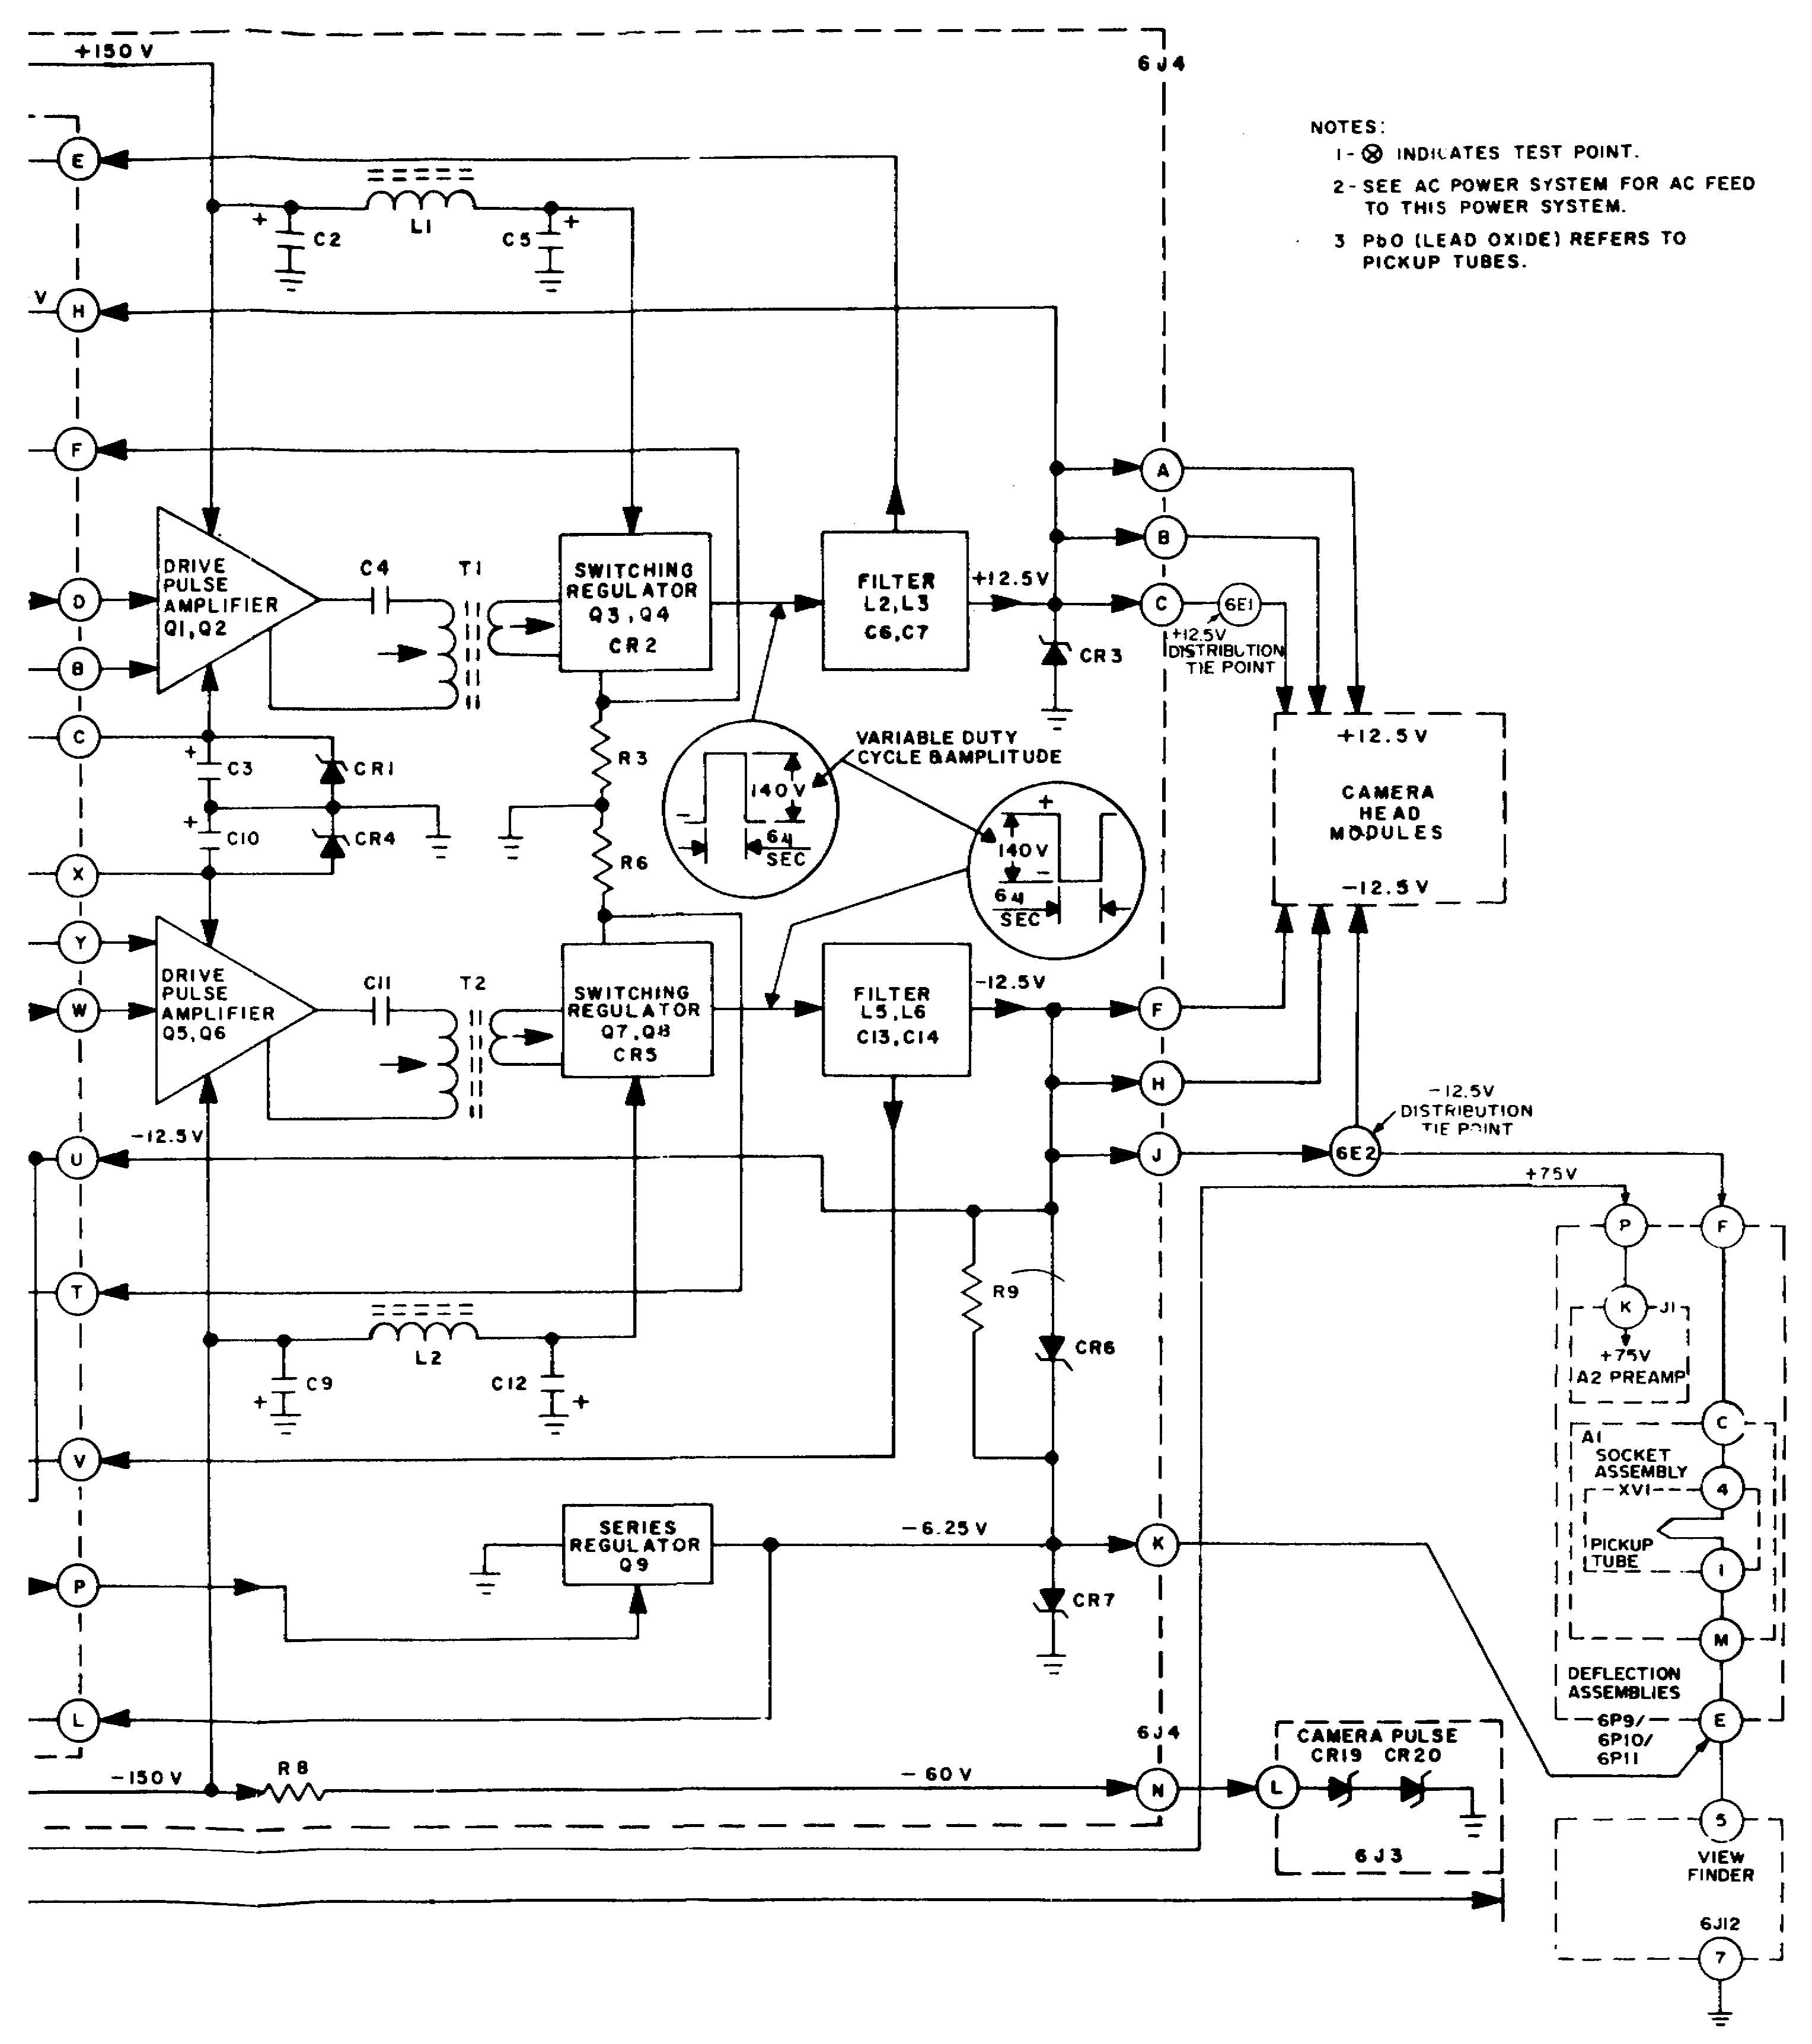

Figure 2-5 (fo). Camera head DC power system, block dia

57C

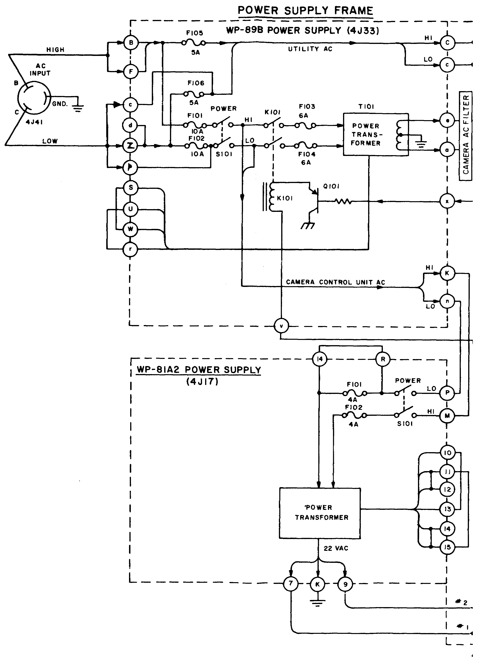

Figure 2-6 (fo). AC power system, block dia

59

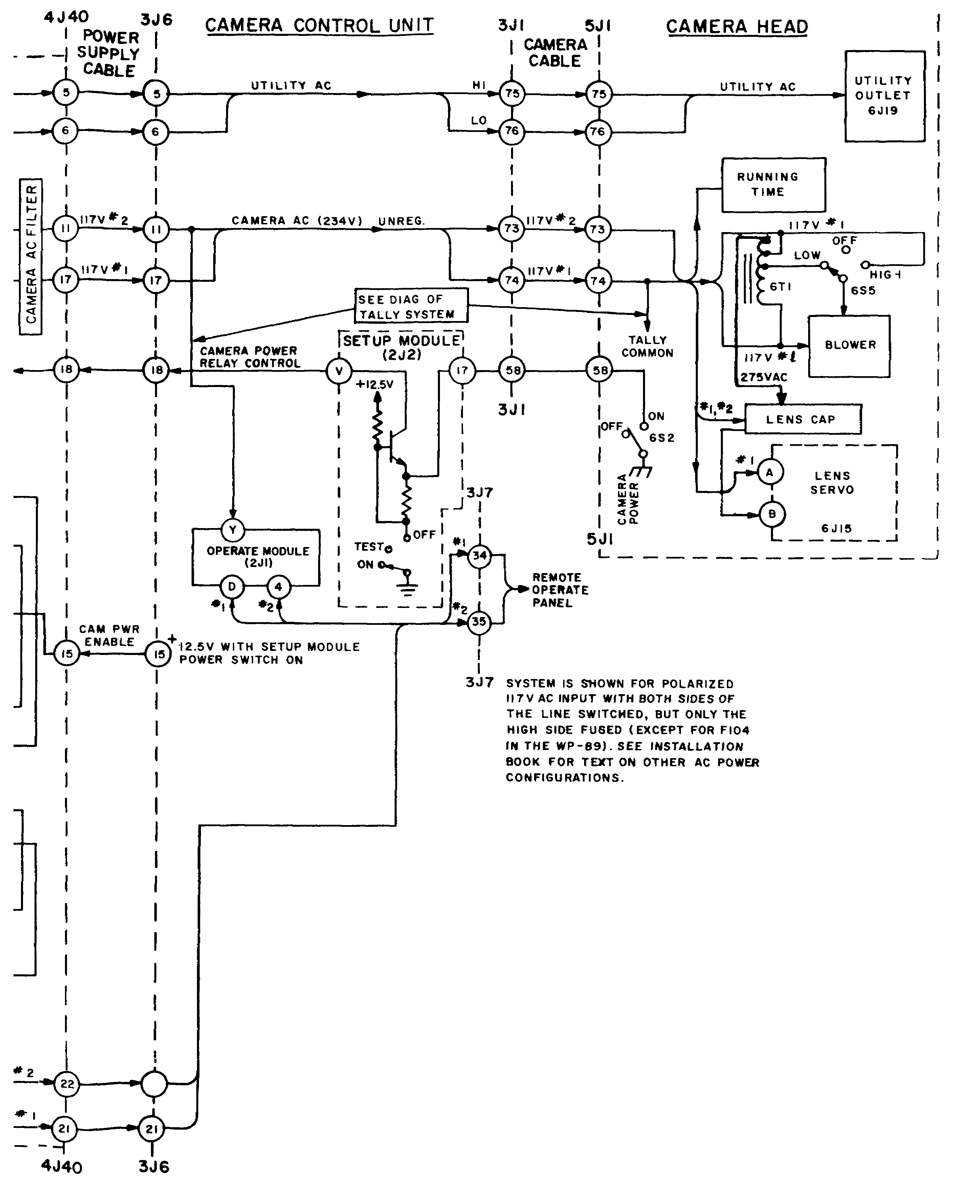

Figure 2-6 (fo). AC power system, block dia

59A

